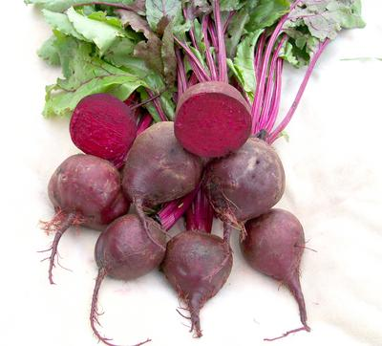
Beet, Detroit Dark Red
Widely adapted, very popular dark red beet. Dark green foliage has some red coloration. Use fresh or canned. Resistant to Downy Mildew. Excellent flavor.

Culture: Light loam of pH 6.5 to 7.0. Ideal soil temperature: 50- 85°F

Spacing: Direct sow 1/2" deep and 4-5" apart. If planting in rows, allow 12-18" between each row.

Irrigation: Provide an inch of water per week. Small, young plants do not require as much water as those close to maturity; however, their relatively shallow roots may need water a bit more frequently until they reach the moisture reserves deeper in the soil.
Fertilization: 1-3 side dressings of fertilizer may be necessary, depending on richness of the soil. Note: Too much nitrogen can cause a lot of leaf growth at the expense of root development.

Maturity: 60 days.

Note: Succession plant at two-week intervals for continuous harvests. All parts of the beet plant are edible.

https://www.southernexposure.com/products/detroit-dark-red-beet/

Compatible with most vegetables and will yield well provided you give them “breathing space” when growing with other plants. Avoid planting beets around pole beans and mustard.

