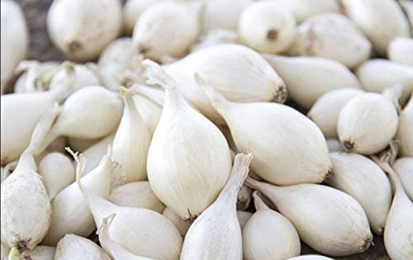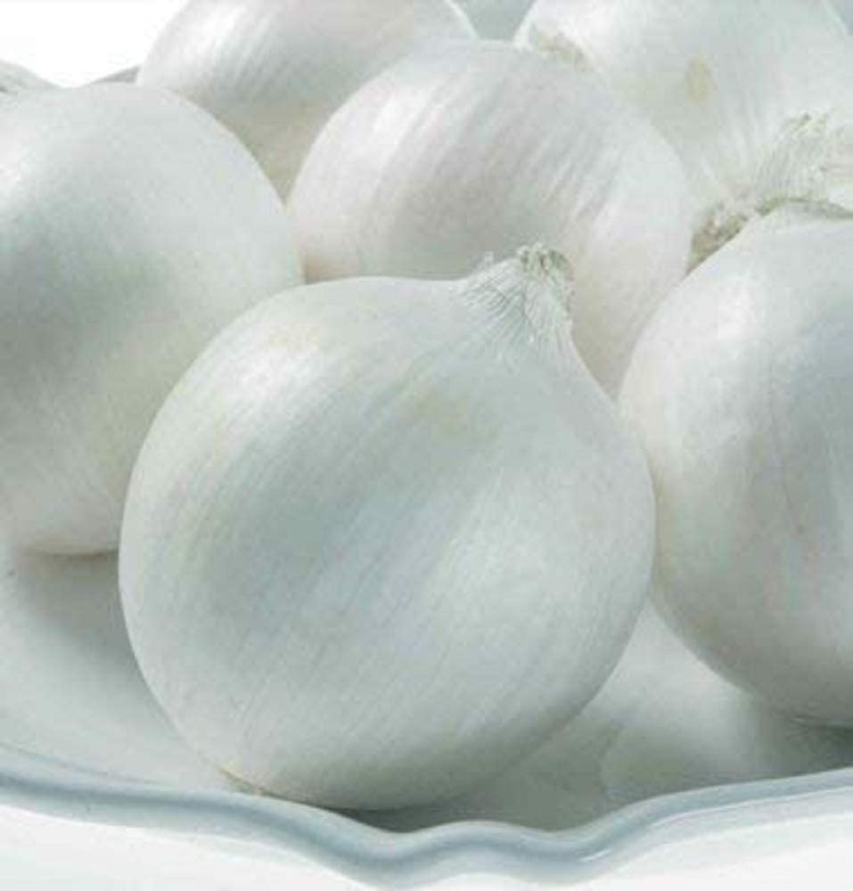
White Onions
Culture: Select a location with full sun, where your onions won’t be shaded by other plants. Dig a trench in the soil about 2 inches deep and 3 inches wide, and then fill the trench back in with about an inch of compost.
Spacing: Set the bulbs 4-5 inches apart with the point end up and push them into damp soil until just the top is showing. When planting in rows, allow 12–18 inches between each row.
Irrigation: Onions need soil that is moist but not wet. (Do not saturate the soil.) On windy or sunny days, onions will require watering to keep the soil moist. Otherwise, watering 2-3 times a week with approximately ½-inch – 1 inch of rain equivalent will keep the soil moist. Onions will look healthy even if they are bone dry, so be sure to water during drought conditions.
Fertilization: Fertilize every few weeks with nitrogen to get big bulbs. Cease fertilizing when the onions push the soil away and the bulbing process has started.
Note: Do not put the soil back around the onions; the bulb needs to emerge above the soil.
Harvest: When onions start to mature, the tops become yellow and begin to fall over. At that point, bend the tops down or even stomp on them to speed the final ripening process. Loosen the soil around the bulbs to encourage drying. When tops are brown, pull the onions and let them cure on dry ground for a few days, weather permitting. Always handle them very carefully—the slightest bruise will encourage rot to set in. Allow onions to dry for several weeks by spreading them out on an open screen off the ground to dry.
https://www.almanac.com/plant/onions#
https://nwdistrict.ifas.ufl.edu/hort/2015/03/24/onions-taste-good-easy-to-grow-and-many-varieties-from-which-to-choose/

Compatible with carrots, beets, cabbage, carrots (repel the carrot fly), lettuce, parsnips, and tomatoes. Trouble with aphids; onions will chase them away! Incompatible with asparagus, beans, and peas.

