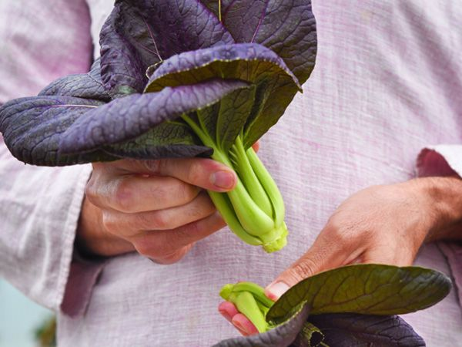

PURPLE LADY BOK CHOY
This eye-catching purple baby bok choy has purple leaves and thick lime green leaf stalks. It is loaded with high levels of antioxidants with anti-aging properties as well as a sweet, rich flavor that is perfect for the wok, grill or in salads. This variety also produces about three times as much vitamin A as regular green type varieties.

Germination Temperature: 50-80°F

Planting Depth: 1/4"-1/2" (If planting a “field” of pak choi, space rows 18-24" apart.)
Seed Spacing: 6-8” (Can be seeded 1-2” apart and the weaker sprouts thinned.)

Maturity: 40-50 days.

Very low in saturated fat and cholesterol, and a good source of dietary fiber, protein, thiamin, niacin and phosphorus. A very good source of Vitamins A, B6, C, and K, riboflavin, folate, calcium, iron, magnesium, potassium and manganese. Note: High sodium content, and large portion of calories come from sugars.
https://nutritiondata.self.com/facts/vegetables-and-vegetable-products/2377/2#ixzz5OwmssIQz

