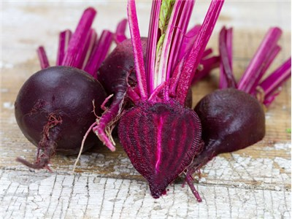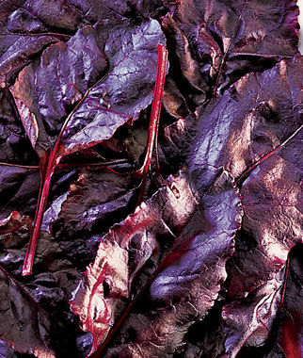
Bull’s Blood Beet
This beautiful beet has deep reddish-purple leaves! Very sweet and delicious, the earliest thinning’s spark up spring and fall salads with a leaf color as richly dark red as radicchio. The beets are tasty too and have pretty pink rings inside. As the roots enlarge, baby beets are also delicious cooked and mixed with salad.

Culture: Light loam of pH 6.5 to 7.0. Ideal soil temperature: 55-75°F Keep beets well weeded. Beets fighting for space become tough and stringy.

Spacing: Sow seed ½", 4" apart. If planting in rows, allow 12-18" between each row. Germinate in 14-21 days.

Irrigation: Provide an inch of water per week. Small, young plants do not require as much water as those close to maturity; however, their relatively shallow roots may need water a bit more frequently until they reach the moisture reserves deeper in the soil (depending on heat, sun, wind conditions).
Fertilization: 1-3 side dressings of fertilizer may be necessary, depending on richness of the soil. Note: Too much nitrogen can cause a lot of leaf growth at the expense of root development. Ideally, use NPK with ratio of 1-2-2.

Maturity: Harvest in 50 days. The small sweet red roots are best when harvested young.

Note: Succession plant at two-week intervals for continuous harvests. All parts of the beet plant are edible.

https://www.seedsavers.org/bulls-blood-organic-beet

Compatible with most vegetables and will yield well provided you give them “breathing space” when growing with other plants. Avoid planting beets around pole beans and mustard.

