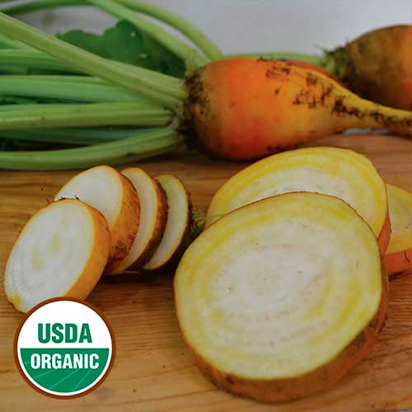
Beet, Yellow Intermediate Mangel
Winner of our 2015 beet evaluation for taste. White- and yellow-ringed roots measure 4-6½" long and vary in shape. While mangel and fodder beets are larger than typical beets and were traditionally used for animal feed, you’ll find the sweet, juicy, and smooth-textured roots are prime for the dinner table and not just the barnyard. Seed Savers Exchange’s seed stock was originally acquired from Dr. Alan Kapuler of Peace Seeds in the 1980s.

Culture: Deep, moist, well-drained soil with near neutral soil pH. Ideal soil temperature: 55-75°F

Spacing: Direct sow 1/2" deep and 4-5" apart. If planting in rows, allow 20" between each row.

Irrigation: Provide an inch of water per week. Small, young plants do not require as much water as those close to maturity; however, their relatively shallow roots may need water a bit more frequently until they reach the moisture reserves deeper in the soil.
Fertilization: 1-3 side dressings of fertilizer may be necessary, depending on richness of the soil. Note: Too much nitrogen can cause a lot of leaf growth at the expense of root development.

Maturity: 65-100 days.

Note: Succession plant at two-week intervals for continuous harvests. All parts of the beet plant are edible.

https://www.seedsavers.org/yellow-intermediate-mangel-organic-beet

Compatible with most vegetables and will yield well provided you give them “breathing space” when growing with other plants. Avoid planting beets around pole beans and mustard.

