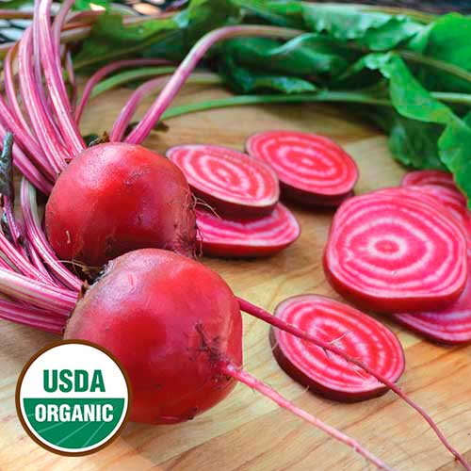
Chioggia Beet
Italian heirloom from the town of Chioggia, a fishing village near Venice, that has been popular since the early 1800s. Sliced roots look like bull's-eyes having concentric rings of white alternating with wine-red. The flesh is very tender, mild, and sweet. The green leaves are an excellent spinach substitute. VISTA gardeners went nearly wild about them during Spring 2018 harvests. Hint: Ask Lori Vella about Chiogga, Italy!

Culture: Deep, moist, well-drained soil with near neutral soil pH. Ideal soil temperature: 55-75°F

Spacing: Direct sow 1/2" deep and 4-5" apart. If planting in rows, allow 20" between each row.

Irrigation: Provide an inch of water per week. Small, young plants do not require as much water as those close to maturity; however, their relatively shallow roots may need water a bit more frequently until they reach the moisture reserves deeper in the soil.

Fertilization: 1-3 side dressings of fertilizer may be necessary, depending on richness of the soil. Note: Too much nitrogen can cause a lot of leaf growth at the expense of root development.

Maturity: Harvest in 54 days. Plant at 2-week intervals for continual harvest. All parts of the beet are edible.

https://www.seedsavers.org/chioggia-organic-beet

Compatible with most vegetables and will yield well provided you give them “breathing space” when growing with other plants. Avoid planting beets around pole beans and mustard.

