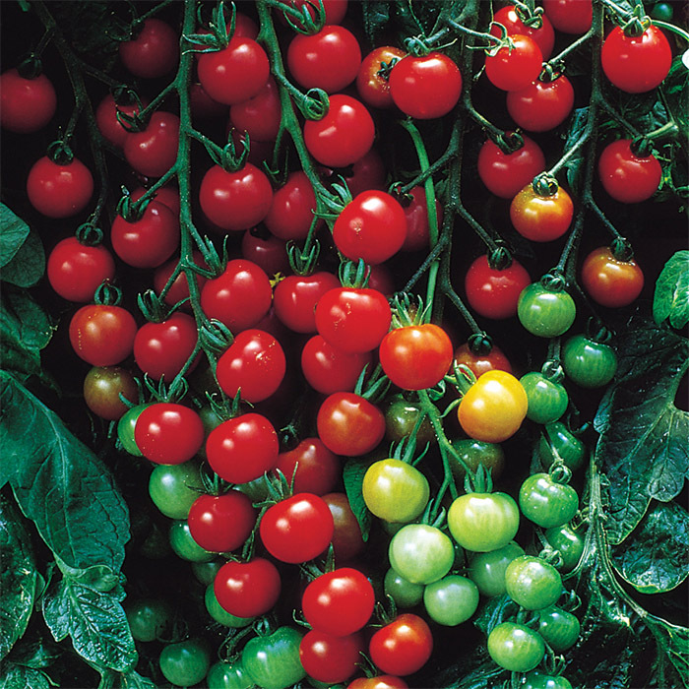
Sweet 100, Hybrid
Sweet 100 tomato plants produce 1 oz., 1” diameter red cherry tomatoes on plants that may grow 4-8 feet tall and produce high yields of fruit from early summer right up to frost. Just one cluster of fruit on the plant can produce up to 100 cherry tomatoes, and the plant can produce many clusters. Good disease resistance against fusarium wilt and verticillium wilt, the only complaint with these cherry tomatoes is that the fruit has a habit of cracking, especially after heavy rains. To prevent this, harvest fruit regularly as it ripens.

Climate: Plants do best with consistent nighttime temperatures between 55˚F. and 75˚F. and may not set fruit in temperatures below 55˚F. or above 90˚F.
Ideal soil pH 6.2 – 6.8.

Spacing: Space seedlings 24-36 inches apart. Transplant so that soil level is just below the lowest leaves. Fit with large cage or trellis support immediately upon transplanting.

Irrigation: Require 1 inch of water each week, depending on weather conditions. Water early in the day and avoid getting water on stem and foliage to prevent disease. Keep soil evenly moist, not wet.

Fertilizer: Granular Nature Safe 5-6-6 and Blood Meal, along with Compost Plus, Micros Plus, and Capacity Plus, used at VISTA at the beginning of the Fall season are good starter fertilizers. Continue regular fertilization with balanced fertilizer. Too much nitrogen causes rampant green growth and limited or soft fruit susceptible to rot. Calcium is helpful in preventing blossom end rot.

Matures 60 days after transplant.

https://www.johnnyseeds.com/search/?q=Sweet+100+Tomatoes&lang=en_US

https://gardeningsolutions.ifas.ufl.edu/plants/edibles/vegetables/cherry-tomatoes.html

Tomatoes are incompatible with broccoli, cauliflower, corn, and dill. Carrots grown with tomatoes will have good flavor but stunted roots. Compatible with basil, beans, chives, cucumbers, garlic, lettuce, marigolds, nasturtium, onion, parsley, and rosemary; all of which help control pests.

