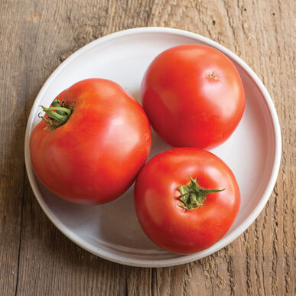
Big Beef
Nice combination of size, taste, and earliness. Large, avg. 10-12 oz., mostly blemish-free, globe-shaped red fruit. They have full flavor - among the best - and ripen early for their size. Broad disease resistance package. High resistance to Alternaria stem canker, Fusarium wilt, gray leaf spot, nematodes, tobacco mosaic virus, and Verticillium wilt. All American Selections (AAS) winner!

Climate: Transplant when soil temperature is at least 60°F. Beefsteak tomatoes will thrive well in mildly acidic soil with pH level between 6.0 and 6.8.

Spacing: Space seedlings 36 inches apart. This plant grows large! Transplant so that soil level is just below the lowest leaves. Train to vertical support or set cage into ground immediately after transplanting.

Irrigation: Require 1-2 inches of water each week, depending on weather conditions. Water early in the day and avoid getting water on stem and foliage to prevent disease. Keep soil evenly moist.
Fertilizer: Granular Nature Safe 5-6-6 and Blood Meal, along with Compost Plus, Micros Plus, and Capacity Plus, used at VISTA at the beginning of the Fall season are good starter fertilizers. Continue regular feeding with a low nitrogen and higher phosphorus and potassium fertilizer that also contains calcium.
Matures 70 days after transplant.

https://www.johnnyseeds.com/vegetables/tomatoes/beefsteak-tomatoes/big-beef-f1-tomato-seed-2063.html

https://gardeningsolutions.ifas.ufl.edu/plants/edibles/vegetables/cherry-tomatoes.html

Tomatoes are incompatible with broccoli, cauliflower, corn, and dill. Carrots grown with tomatoes will have good flavor but stunted roots. Compatible with basil, beans, chives, cucumbers, garlic, lettuce, marigolds, nasturtium, onion, parsley, and rosemary; all of which help control pests.

