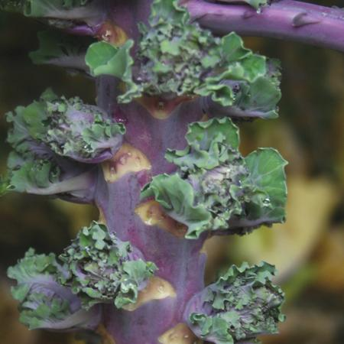
Autumn Star Kalette
A bite-sized kale! Through traditional breeding methods, over several years, crosses between brussels sprouts and kale have resulted in Kalettes. The complex flavor of sprouts is combined with the mild, nutty taste of kale resulting in a floret that is easy and versatile in the kitchen. The green and purple, bicolor florets are produced on brussels sprout like plants and are ready to harvest when 2" tall. Enjoy them raw, grilled, broiled or sauteed.

Climate: Kale prefers a fertile, well-drained soil high in organic matter with a pH 6.5–7.5. Avoid planting where any member of the cabbage family grew in previous years. Kale prefers cooler growing temperatures, between 55–75°F, optimum being 60–70°F, but will produce good crops under warmer, summer conditions.

Spacing: 18 inches apart

Irrigation: Water regularly, especially in dry weather.

Fertilization: Kalettes prefer nitrogen-rich soil. Add a couple of inches of compost and/or well-aged manure to your garden soil before setting your kalettes out. You can add a pinch of blood meal at the roots of each plant for a nitrogen boost. Spray every 2 weeks with fish emulsion or compost tea for a further nitrogen boost.

Pinch off the growing tip of the plant once the lowest rosettes on the stem are 1/2″-3/4″ wide. Pinched tops can be cooked and eaten like kale

Harvest florets when they are approximately 1½-2 inches in diameter. A light frost will improve flavor.

Days to Maturity – 110

https://www.vermontbean.com/product/V01458/75

https://www.gardeningchannel.com/how-to-grow-kalettes-new-superfood-the-kale-and-brussels-sprouts-vegetable-hybrid/

Kale is compatible with beets, celery, cucumbers, dill, lettuce, nasturtium, onions, spinach, Swiss chard, and many herbs (especially in the mint family). It is incompatible with tomatoes and strawberries.

