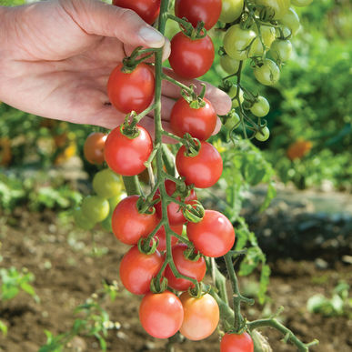
Sunpeach
Sunpeach (sister variety to Sun Gold, is not as tangy and acidic as its famous orange relative, but is very sweet with excellent flavor.) Deep pink, shiny, 15-20 gm., cherries are borne on long trusses. Vigorous, healthy, high-yielding plants. High resistance to leaf mold helps it stay healthy in high tunnels; also has high resistance to tomato mosaic virus. Resistant to cracking.

Indeterminate: Train to a vertical support and prune for best results.

Space seedlings 24 inches apart. Transplant so that soil level is just below the lowest leaves.

Fertilize to ensure abundant soil phosphorus for early high yields. Too much nitrogen causes rampant growth and soft fruits susceptible to rot. Abundant soil calcium and an even supply of soil moisture prevents blossom end rot.

Maturity/Harvest: 60 days from transplant

Tomatoes are compatible with basil, beans, chives, cucumbers, garlic, lettuce, marigolds, nasturtium, onion, parsley, and rosemary; all of which help control pests. Tomatoes are incompatible with broccoli, cauliflower, corn, and dill. Carrots grown with tomatoes will have good flavor but stunted roots.

