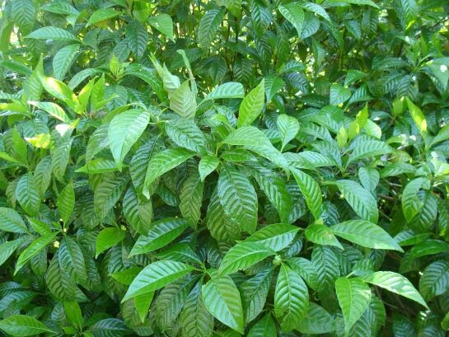

Shiny Coffee
Psychotria Nervosa

Native shrub, also known as Wild Coffee, with deep green, shiny and evergreen leaves. Bears clusters of small white flowers that bloom from the branch tips in spring/summer and produce red fruit in summer/fall. The fruit resembles true coffee beans, but they do not contain caffeine. While wild coffee is in the same family as true coffee (Rubiacaea), they are not the same species.
These shrubs reach anywhere from 4 to 10 feet tall and spread 4 to 8 feet wide with a very dense growth habit. Cultivars of wild coffee, such as the dwarf shrub “Little Psycho” can be found in the plant trade.
Birds and other wildlife are attracted to the wild coffee fruits. The flowers are one of the nectar sources for the rare Atala butterfly found primarily in southeast Florida.

https://www.wilcoxnursery.com/?s=Coffee+

https://gardeningsolutions.ifas.ufl.edu/plants/trees-and-shrubs/shrubs/wild-coffee.html

