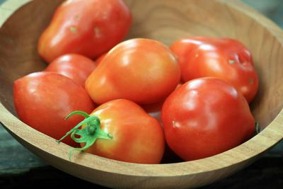
Roma VF Tomato Paste (Determinate*)

Pear-shaped paste tomato. Fruit ripens uniformly. Highly productive, good resistance to disease and fruit-worm.

Culture:

Spacing: 24" apart. Transplant so that soil level is just below the lowest leaves.

Irrigation: If fruit cracks, reduce watering.

Fertilization: Apply well-balanced fertilizer, although with a bit higher phosphate level to increase early yields. Too much nitrogen causes excessive vegetation at the expense of fruiting. Blossom-end rot is prevented by ensuring an adequate level of soil calcium and steady moisture.

Maturity/Harvest: 75 days

https://www.southernexposure.com/products/roma-vf-paste-tomato/

Tomatoes are incompatible with broccoli, cauliflower, corn, and dill. Carrots grown with tomatoes will have good flavor but stunted roots. Compatible with basil, beans, chives, cucumbers, garlic, lettuce, marigolds, nasturtium, onion, parsley, and rosemary; all of which help control pests.

*Determinate varieties are short-vined plants that do not require trellising, though yields will be much better if plants are staked. Pruning of determinate varieties should be kept to a minimum.

