Winter squash – Vegetable Spaghetti
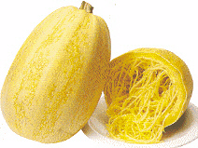

This Japanese strain open-pollinate variety has spaghetti-like flesh after it is boiled or baked. Harvest when fruit reaches 6"- 8" in diameter. For a low-calorie "pasta" meal, bake or boil, then fork out the yellow flesh and serve with spaghetti sauce.

Matures in 90 days – Harvest when fruit reaches 6-8" in diameter.

Cultivation: Prepare fertile, well-drained soil and form a 1-foot diameter mound 3-4" tall. Space mounds 3 feet apart. On each mound plant 3-4 seeds ½" deep and 2" apart.

https://www.kitazawaseed.com/seed_085-187.html

