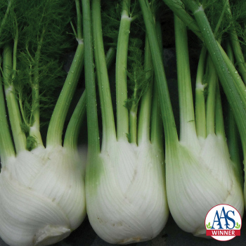
Florence Fennel
2017 All-America Selections Winner. This fennel was a clear winner over the competition, because it is slower to bolt and its improved licorice/anise flavor. Judges observed that the plants produced more uniform bulbs, too. Its ferny leaves provide valuable food for swallowtail butterfly caterpillars.

Culture: Moist, rich, and well-draining soil amended generously with compost at time of seeding. Ideal soil temperature 60-75°F.

Spacing: Sow seeds ¼" deep, 8" apart.

Irrigation: Newly planted seeds will require watering every day until the set of mature leaves emerges, then taper back watering to three times a week, then twice a week.

Fertilization: To much fertilizer can lead to lush green growth with low volitale oils in the plant. Less oils equals less flavor and aroma for your herbs. However, when planting into Florida’s sandy soils you may find your plants in need of a boost. If so, try fertilizing with a mixture of organic fish emulsion or seaweed at one ounce of each per gallon of water. Put into a sprayer and water every other week. If your leaves still look a bit lackluster, consider a bit of alfalfa or blood meal.
Or, if you find your plant struggling at any point, make up a batch of compost tea and water generously. Repeat as needed weekly or biweekly.

http://sjgardensharvest.com/Growing-Fennel-in-Northeast-Florida.html

Maturity: 68 days. Plant grows to 24" with fruit 4-5". Harvest in the morning just after the dew is off the leaves.

https://www.vermontbean.com/product/V02442/7

Not a companion for any garden food plant, fennel will inhibit growth in bush beans, kohlrabi, tomatoes, and others. Plant it, but keep it out of the veggie garden.

Fennel attracts hoverflies, ladybird beetles, parasitic wasps, and tachinid flies, so it's a kind of beneficial insect magnet.

https://www.westcoastseeds.com/blogs/garden-wisdom/companion-planting#:~:text=Fennel

Note: VISTA Gardeners often raise fennel in grow bags set at the end of their raised beds.

