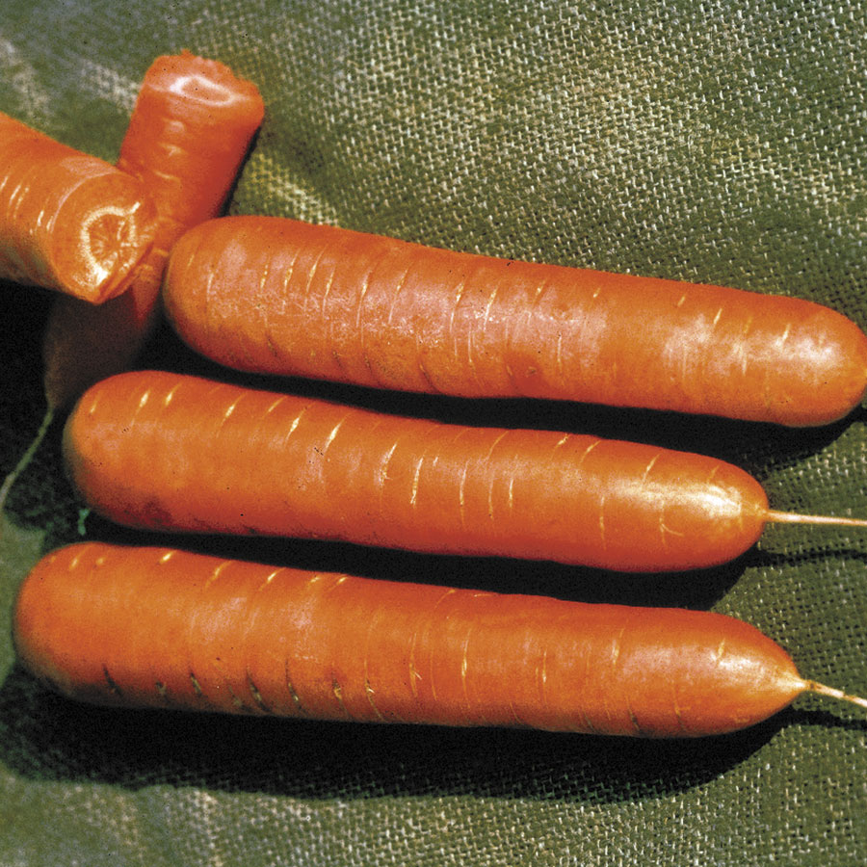
Nantes, Organic
Nantes is an exceptionally sweet variety just made for slicing and produces earlier than many carrot varieties. The 6 to 7-inch roots are firm, straight, and not tapered, with inconspicuous cores and plenty of tender, crisp, and ultra-sweet flavor. This is the classic name in carrots, and now it is available from organic seed. Higher in vitamins A and B than their store-bought counterparts, homegrown carrots are also rich in calcium and phosphorus—and they taste delicious. And with this certified organic variety, you know you are growing nothing but nature's goodness.

Culture: Loosen soil and work in organic matter.

Spacing: Sow seeds ¼-½ inch deep, barely covering with soil. They need light to germinate (typically in 14-21 days). When carrot tops reach 2-inches in height, gently thin them to be 4-6 inches apart. Use a small scissor to cut rather than pull, so that you do not disturb neighboring carrot roots.

Irrigation: Carrots like good drainage and regular watering, although the soil should be moist and not saturated. It is important not to allow soil to dry out.

Note: When the tops of the carrots begin to emerge form the soil, cover them with soil or organic mulch to keep them tender. Keep weeds under control to avoid carrots from becoming stunted.

Fertilization: When carrot tops are 3" high, apply fertilizer that is low in nitrogen and higher in potassium. Excessive nitrogen results in carrot roots cracking and splitting.

Maturity: 62 days.

https://parkseed.com/organic-nantes-carrot-seeds/p/05879-PK-P1/

Carrots are compatible with beans, Brassicas, lettuce, onions, peas, peppers, pole beans, radish, and *tomatoes.

Avoid planting with dill, parsnips, and potatoes.

Generally speaking, it is a good idea to keep some space between root crops so they don’t compete for available phosphorus.

Planting carrots with aromatic herbs or onions may repel the carrot fly and its maggot. Chives also benefit carrots. Other compatible herbs include rosemary and sage.

*Carrots planted near tomatoes may have stunted roots, but will have exceptional flavor.

