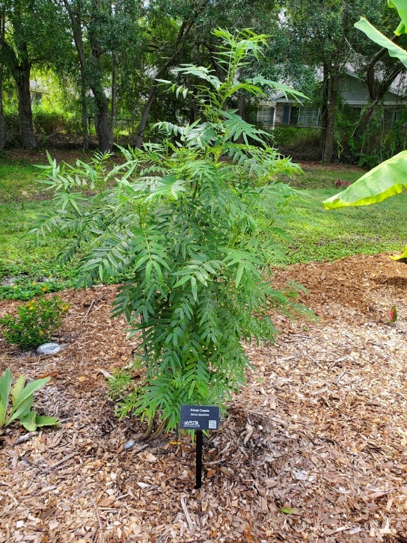
Privet Cassia
Senna ligustrina

A fairly easy growing plant that reaches 6-7 ft. in height and about the same in spread. It has medium green elliptical leaves and the plant has a soft lacy texture. It has a yellow showy flower clusters on the end of the branches in the fall and spring. Its fruit is a dry brown pod (legume). Grows quickly, prefers full sun to partial sun in well-drained soil, and is a bit more cold hardy than closely related Bahama Cassia.
This is a great butterfly plant since it is a host for several species of Sulfur Butterflies and is also attractive for nectar.
https://www.wilcoxnursery.com/store/Privet-Cassia-p190033150
Long-lived perennial shrub recommended as specimen plant.
Larval host plant for cloudless sulphur (Phoebis sennae), sleepy orange (Eurema nicippi) and the introduced orange-barred sulphur (Phoebis philea) butterflies.
Sennas attract butterflies, solitary bees including sweat bees and bumble bees, as pollinators.
https://fnps.org/plant/senna-ligustrina

