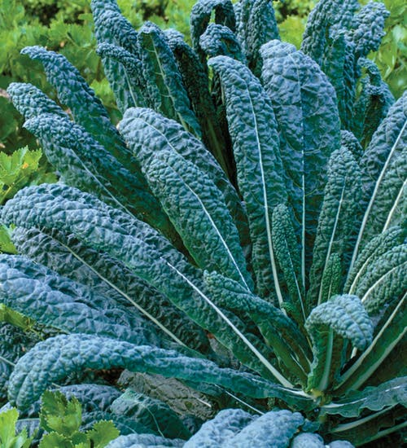
Nero Di Toscana Cabbage
Palm cabbage Nero di Toscana is a very tender and juicy kale variety called palm cabbage because the plant looks just like a little palm tree. It originates from Tuscany and is also known as dinosaur, Lacinato or Tuscan kale. A hardy, non-heading variety that produces juicy, very tender and delicious dark green leaves that have the best flavor when harvested young. Use in mashed potato stews, in oven dishes, stir-fries and as a delicious and healthy vegetable.
If direct sowing, seed every 4-6 inches, ¼" deep and thin to mature spacing of 12-24” apart. If transplanting, allow plenty of space as these grow large and plant in firm – not loose – soil.
Fertilize: Work in fertilizer (Territorial Seeds recommends their complete fertilizer 6-5-3) before transplanting, although do not work soil loosely, as transplants do best in firm soil.
Irrigation: Consistent moisture provides the best tasting leaves. Moist, but not soggy soil is ideal.
Harvest in about 2 months after planting by clipping individual leaves from the bottom up at any size. Cut and come again!
Very hardy, and the eating quality improves with light frost.

