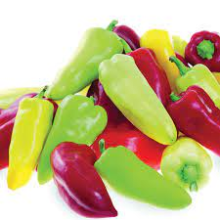
Pretty N Sweet Hybrid Pepper
2015 AAS Winner. Now gardeners have an ornamental pepper that can be eaten -- and it tastes fantastic. Sweet, multicolored peppers on compact, 18" plants are very attractive in ornamental gardens and containers. Compared to similar varieties, it's earlier, more prolific (harvest weekly in peak season), has thicker walls and a much sweeter taste to enjoy fresh or in your favorite pepper recipes.
Climate: Full sun. Ideal soil temperature 65-85˚F. Best soil pH between 6.0-6.8. Well-draining soil rich with organic amendments.
Spacing: 18-24 inches apart in raised beds
Irrigation: Water the plants regularly, giving them at least 2 inches of water per week during dry weather. Check the soil moisture by sticking your finger into the soil; water any time it feels dry an inch beneath the surface. Irrigate the base of the plant and avoid getting water on the foliage. Keep soil moist, but not soaking wet.
Fertilizer: Fertilize your growing banana pepper plant with organic vegetable fertilizer twice a month. NPK of 4-6-8 is ideal. Avoid using high nitrogen fertilizer, else you’ll get more vegetative growth than fruits.
Matures 60 days after transplant.
https://www.totallytomato.com/product/T03204/
https://gardeningsolutions.ifas.ufl.edu/plants/edibles/vegetables/peppers.html
Peppers are compatible with tomatoes, carrots, cucumbers, radishes, squash, eggplant, spinach, lettuce, chard, onions, and peas. They benefit from the company of nasturtiums, geraniums, and petunias.

Peppers are incompatible with pole beans, mustards, soybeans, lima beans, fennel, cabbage, broccoli, Brussel sprouts, cauliflower, collards, kale, turnips, and strawberries.

