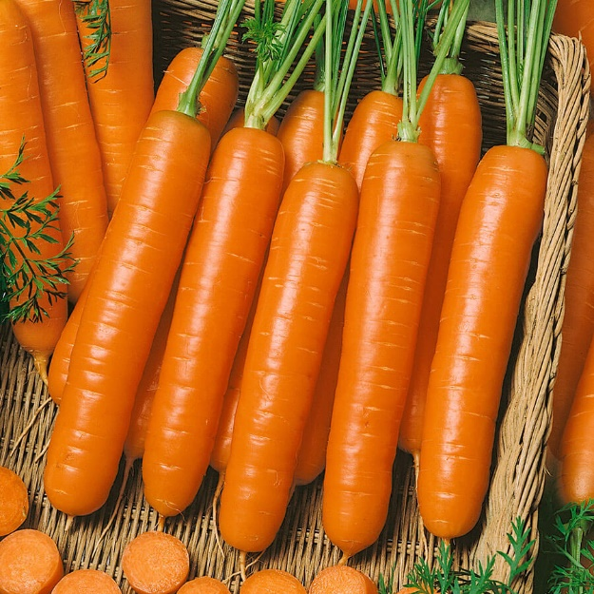
Little Finger, Organic
Extra-sweet organic baby carrot is really the size of your little finger. Growing only about 4 inches long, it is a classic baby variety with a crisp consistency and juicy bite. The dark orange roots are smooth and do not taper. Higher in vitamins A and B than their store-bought counterparts, homegrown carrots are also rich in calcium and phosphorus.

Culture: Loosen soil and work in organic matter.

Spacing: Sow seeds ¼-½ inch deep, barely covering with soil. They need light to germinate (typically 14-20 days). When carrot tops reach 2-inches in height, gently thin them to be 4-6 inches apart. Cut tops rather than pull, so that you do not disturb neighboring carrot roots.

Irrigation: Carrots like good drainage and regular watering, although the soil should be moist and not saturated. It is important not to allow soil to dry out.

Note: When the tops of the carrots begin to emerge from the soil, cover them with soil or organic mulch to keep them tender. Keep weeds under control to avoid carrots from becoming stunted.

Fertilization: When carrot tops are 3" high, apply fertilizer that is low in nitrogen and higher in potassium. Excessive nitrogen results in carrot roots cracking and splitting.

Maturity: 60 days. Harvest the roots as soon as you want, but certainly when they are less than 2 inches across; the smaller the tastier.

https://parkseed.com/carrot-little-finger-organic-seeds/p/52891-PK-P1/

Carrots are compatible with beans, Brassicas, lettuce, onions, peas, peppers, pole beans, radish, and *tomatoes.

Avoid planting with dill, parsnips, and potatoes.

Generally speaking, it is a good idea to keep some space between root crops so they don’t compete for available phosphorus.

Planting carrots with aromatic herbs or onions may repel the carrot fly and its maggot. Chives also benefit carrots. Other compatible herbs include rosemary and sage.

*Carrots planted near tomatoes may have stunted roots, but will have exceptional flavor.

