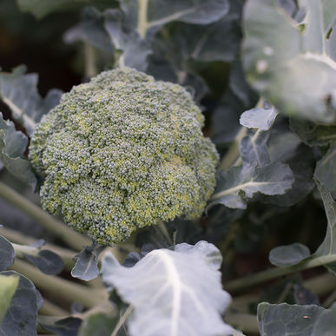
Broccoli – Marathon
Marathon has a high dome, small bead and heavy head. Heat tolerant but unique because it keeps growing even in cooler temperatures, so it is perfect for a fall crop in the South.

Spacing: 24" A one-inch layer of mulch keeps the soil surface much cooler and reduces the threat of bolting.

Irrigation: Regular, steady watering of 1-1½" per week is important during hot, dry weather. Overhead watering in hot weather can drop the temperature around the plants 10° F, due to evaporation, which is good for young plants, but should be avoided once heads start forming (to reduce the risk of soft rots setting into the crowns.)

Fertilization: Broccoli is a heavy feeder. Use a balanced fertilizer at the time of planting and repeat three applications: 1) when plant grows to 6-8 inches in height, 2) when plant is 12-15 inches tall, and 3) when the buds first form. Broccoli also benefits from supplemental calcium in the soil. (If your fertilizer does not contain calcium, you can mix ground oyster shell or dried, crushed eggshells and into the soil at the time of planting). See tips below.

Matures in 75 days. Fertilize when first head is cut to get more side shoots and an extended harvest.

https://www.johnnyseeds.com/vegetables/broccoli/standard-broccoli/marathon-f1-broccoli-seed-151.html

Extra Growing Tips:

The trick to producing good broccoli is to keep it growing steadily. Two to three weeks after transplanting, top dress with compost tea or side-dress with blood meal or fish emulsion, and water deeply. Repeat monthly until a week before harvesting the flower head. This regimen also encourages large and tender side shoots, which you can harvest until hot weather.

Cultivate around young plants to get rid of weeds and keep the soil loose. If daytime temperatures exceed 75°F, put down a thick layer of organic mulch to cool the soil and conserve moisture. Broccoli needs steady 1 - 1½ inches of water a week (slightly less during fall months.) A lack of water will result in tough stems.

Compatible plants include carrot, celery, cucumber, lettuce, radish, shallot, spinach, and Swiss chard. Because broccoli is a notorious calcium-hog, plants that require little calcium (e.g. beets, nasturtiums, marigolds) are good companion plants.

Incompatible plants include peppers, mustard greens, pole beans, lima beans, snap beans, squash, and strawberries. Since broccoli is a heavy feeder, other heavy-feeding plants are not good companions (cantaloupe, pumpkin, sweet corn, and watermelon).

