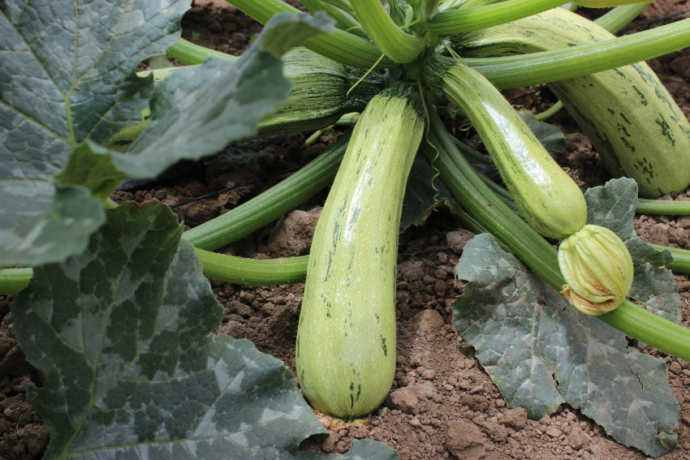
Summer squash – Bossa Nova
A 2015 winner of the All America Selections award for improved earliness and lateness (meaning that it keeps producing nearly a month after others have quit for the season), terrific texture and flavor, plus charming green-on-green stripes and mottles that make the fruit easy to see among all those shadows and dark green leaves when you're harvesting.

Bossa Nova will be fighting the diseases problems of zucchini yellows virus, and watermelon mosaic virus – resistances that many other squash do not offer, and its earliness helps protect it from squash borers.

The vine is quite compact, reaching 4 feet long, and easy to train up a fence or other sturdy support if your garden is space-challenged.

Culture: Well-drained, sandy loam that is high in organic matter. It's very important to keep the plants weeded

Spacing: 1 inch deep, 24 inches apart. Or you can plant several seeds in “hills” 4 feet apart and then thin to 2 plants per hill.

Irrigation: Squash requires regular and even watering. Keep the soil just moist. Avoid overhead watering (to prevent damaged, diseased leaves from Powdery Mildew.)

Fertilization: Fertilize before planting and then again every 3 weeks until you harvest. Squash are heavy feeders. A balanced fertilizer is ideal; nitrogen will help with the plant growth, potassium and phosphate will help with fruit production.

Squash blossoms are also edible!

Maturity: 30-45 days. Harvest when 6-8 inches and do so frequently!

https://parkseed.com/bossa-nova-hybrid-squash-seeds/p/52581-PK-P1/

https://all-americaselections.org/product/squash-bossa-nova/

Grow squash with celeriac, celery, corn, nasturtiums, melons, onions, radishes, peas, and beans. Avoid growing squash with potatoes.

