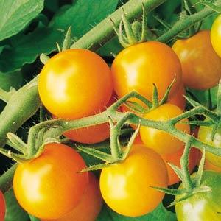
Sun Gold, Hybrid
Bright tangerine-orange cherry tomatoes from Japanese origin, this orange cherry variety has an incredibly sweet, almost fruit-like flavor and is rapidly becoming the most popular cherry tomato of all time. Fruits are borne in large clusters and the flavor develops early, so this little tomato is great for snacking a week before full maturity, when it becomes very sweet and delicious.

Indeterminate: Train to a vertical support

Vigorous plants start yielding early and bear right through the season. High resistance to fusarium wilt and tobacco mosaic virus.

Space seedlings 20 inches apart. Transplant so that soil level is just below the lowest leaves.

Fertilize as needed. Too much nitrogen will produce lush foliage and few fruits.

Maturity/Harvest: 60 days after transplant

Tomatoes are compatible with basil, beans, chives, cucumbers, garlic, lettuce, marigolds, nasturtium, onion, parsley, and rosemary; all of which help control pests. Tomatoes are incompatible with broccoli, cauliflower, corn, and dill. Carrots grown with tomatoes will have good flavor but stunted roots.

