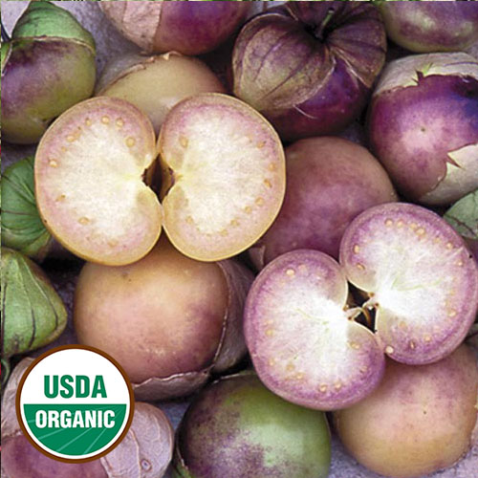
Purple Tomatillo (Tom-a-TEE-yo)

Dark purple fruits are smaller (1½-2") and have a sweeter flavor than green tomatillos. Makes an attractive purple salsa, also great grilled. Noticeably less sticky than most tomatillos. Culture is very similar to tomatoes.

Note: Plant 2 tomatillo plants, for pollination and fruit production. Tomatillos are self-sterile, meaning the flowers of an individual plant cannot pollinate themselves. You will need more than one plant to get fruit.

Climate: Full sun. Tomatillos prefer a somewhat neutral soil pH around 6.5 - 7.0, but for the most part, they will grow anywhere there is heat, sunshine, and regular water. Well-draining soil rich with organic amendments.

Spacing: 24-48 inches apart. Trellis to keep foliage off the ground and to contain the plant.

Irrigation: Water the plants regularly, giving them at least 1-2 inches of water per week, depending on weather. Check the soil moisture by sticking your finger into the soil; water any time it feels dry an inch beneath the surface. Irrigate the base of the plant and avoid getting water on the foliage. Keep soil constantly moist, but not soaking wet.

Fertilizer: When transplanting, work a fertilizer with equally balanced NPK (e.g., 10-10-10) into and around the planting hole. After harvesting the first fruit, apply a ½ cup low nitrogen and higher phosphate and potassium (e.g., 5-10-10) fertilizer. This second feeding helps tomatillos continue flowering and producing fruit.

Maturity: 90 days after transplant. A netted, papery husk around the fruit begins to dry when fruits are maturing. Harvest tomatillo when they are firm to the touch but seem to give a little. Ripe fruits will pull easily from the plant.

Note: Store tomatillos at room temperature. Fruits will continue to ripen after being picked if they are stored in a warm place.

https://www.seedsavers.org/purple-organic-tomatillo

Tomatillo can be sliced into a fresh salsa, canned as a salsa verde sauce, or pureed to make a sauce for carnitas or tacos. Fruits can also be broiled and pureed with chili peppers for a different take on salsa verde. If you are given a bumper crop of tomatillo, try canning a green salsa at home.

https://www.seedsavers.org/grow-tomatillo

Companion plants include peppers, carrots, onions, and brassicas. Also, marigolds and nasturtium attract pollinating bees. Basil repels insect pests.

Incompatible plants include kohlrabi, which stunts the growth of tomatillo plants. Both dill and fennel contain oils that inhibit root growth and could destroy neighboring plants.

