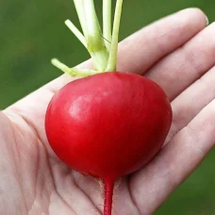
German Giant
Scarlet with a white interior, these large radishes can grow to the size of a baseball and remain sweet and crisp. They resist cracking. Begin harvesting when radishes are the size of a quarter.
Culture: Optimum soil pH between 5.5 and 6.8. Loosen top 6"of well draining soil and work compost into the top 2".
Spacing: Sow seeds 1/4" deep in moist soil, 3 -4" apart, in rows 8-12". Germinate in 4-10 days. Planting successively every week allows for continuous harvesting.
Irrigation: If plants do not receive one inch of rain weekly, water deeply. Drought stress can cause the roots to develop poor flavor and a tough texture.
Fertilization: Radishes do not require additional fertilization after they are planted. Be careful not to use nitrogen-rich fertilizers near radishes, as you will prompt leaf growth at the expense of radish root.
Maturity: 29 days.
https://www.vermontbean.com/product/V03365/90
Plant radishes near beans, beets, celeriac, chervil, cucumber, lettuce, mint, parsnip, peas, spinach, squash, and tomatoes. Avoid planting near potatoes.

