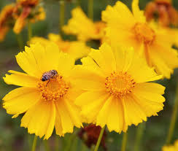
Dwarf Lance Leaved Coreopsis
“This plants blazing brightness and heat-tolerant, drought-loving growth has made it one of the most well-known native wildflowers, as well as being a popular choice of beginning gardeners and master gardeners alike. … The flowers of this family have become especially well loved by Floridians, who appointed coreopsis as the official state wildflower in 1991.” https://www.everwilde.com/store/Coreopsis-lanceolata-dwarf-WildFlower-Seed.html
- Plant adapts to any soil, although if soil is too moist or rich the plants may flop and need support.
- Attracts bees and butterflies, as well as resisting deer and rabbits.
- Regular deadheading helps prolong blooming. Cut stems long and immediately place in water.
- Several weeks after flowering fades, seed heads will turn dry and dark brown. The seeds are a favorite food of songbirds and rodents, so harvest promptly by cutting heads from plants and spreading out to dry. When dry, break them apart to remove the seeds, separate seeds from the chaff and store seeds in a cool, dry place.

