Summer squash – Teot Bat Put
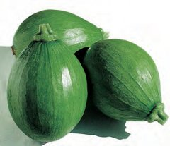
This summer squash is nicknamed avocado squash because of its shape. It has glossy deep green skin, light yellow flesh, and a wonderful, sweet flavor. With moderate plant vigor, it is easy to grow and has good fruit set due to short internode spacing and a narrow stem. Ripe fruits measure about 4" in diameter and about 6" in length.

Warm season annual that matures in 65-70 days

Cultivation: Squash prefers warm temperatures. Prepare fertile, well drained soil. Sow seeds in spring/summer after last frost in a warm, sunny location. Hill planting: Form soil into a 1 ft. diameter mound 3-4" tall. Space mounds 3-4' apart. On each mound plant 1-2 seeds. Row planting: See spacing info in chart. Keep soil moist. Fertilize as needed. Train to climb a vertical support for better air circulation and ease of harvest or leave to sprawl on the ground.

Germination  Temperature | Seed  Depth | Seed  Spacing | Thin  To | Row  Distance
70-95°F | 1" | 10-12" | 24-30" | 48-60"

Enjoy as a freshly sliced snack, sauté, stir-fry, or even grate for zucchini bread.

https://www.kitazawaseed.com/seed_441-188.html

