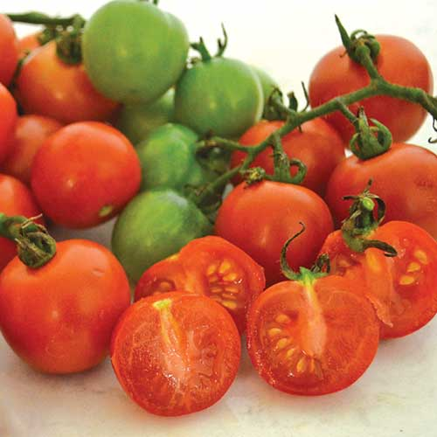

Tomato, Tommy Toe
Solanum lycopersicum

- Red cherry tomato
- Superb flavor
- Very productive
- Indeterminate - Fruit ripens throughout the season
- 70 days from transplant

Exceptionally vigorous plants yield hundreds of large red cherry tomatoes throughout the season. The superb flavor won it top billing over 100 other varieties in an Australian taste test.
Transplant outdoors in full sun, allowing 24-36 inches between plants. Support with cage, trellis, and/or stake.

