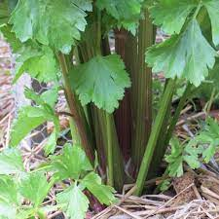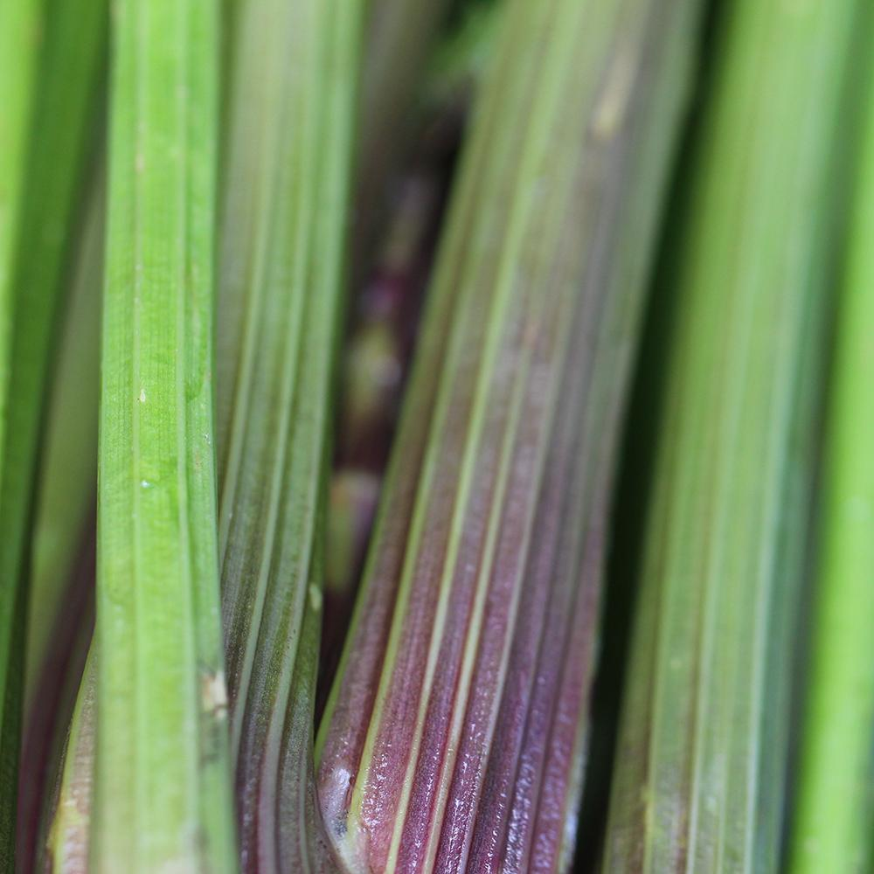
Celery, Peppermint Stick
ORGANIC. Thin, striped pink and green stalks pack a potent celery flavor with a surprising sweetness. Color tends to remain even when cooked. Excellent for soups and stews, for a relish tray, a surprise in your Bloody Mary, or for fresh snacking. The plants are so interesting and beautiful they work well as specimen plantings tucked into your flower beds!
Culture: Fertile soil with a pH range of 6.0–7.0. A generous amount of compost worked deeply into the soil before planting helps retain moisture and add nutrients. Ideal soil temperature is 50-70°F. Moderately frost tolerant.
Spacing: Sow seed 1/16" deep. Space 8-14" apart. Germination is slow, typically 10-20 days.
Irrigation: Roots of celery rarely extend more than 8" in any direction and so must be kept well watered. Consider mulching with food-grade straw to conserve soil moisture.
Fertilization: Apply every 3-4 weeks with a high potassium fertilizer (4-4-8, for example).
Maturity: 115 days.
https://sowtrueseed.com/products/celery-peppermint-stick-organic
Compatible with bush beans, cabbage, cauliflower, onions, spinach, and tomatoes. Do not plant with carrots, parsley, parsnips, or turnips as they will compete for the same moisture and nutrients.

