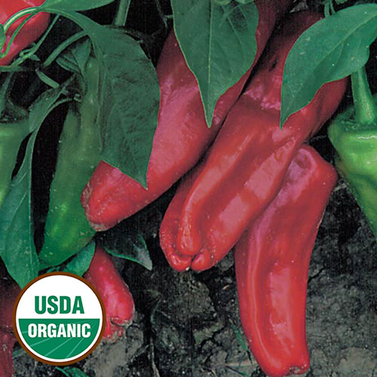
Marconi Red Pepper - Sweet

Prolific Italian variety prized for its gigantic sweet red fruits. Delicious 12" long 3” across (at shoulders) peppers are ideal for stir-fry, grilling and enjoying raw in salads. An early variety known for its high yields.

Space: Transplant 18” apart, grows to height of 24”-36”

Irrigation: Peppers require deeply-worked, well-drained soil with plenty of added organic matter and a pH of 6.0-6.8. Water deeply, but don't over water. A humidity tolerant variety.

Fertilize: Avoid an overabundance of green growth and very little fruit production by fertilizing with low nitrogen and higher phosphorous and potassium fertilizer (e.g., 5-10-10.)

Mature 70-90 days after transplant. Harvest the first fruits early to encourage continued production through the season. Tip: Cut (don't pull) the fruit from the stems. These peppers may be harvested from the green stage through the color changes. Sweetest when red.

Peppers are compatible with many herbs and flowers, as well as tomatoes (although rotate where they are planted from year to year), carrots, cucumbers, radishes, squash, eggplant, spinach, lettuce and chard. Peppers are incompatible with plants in the Brassica family (Brussel sprouts, broccoli, cabbage, kale, etc.)

