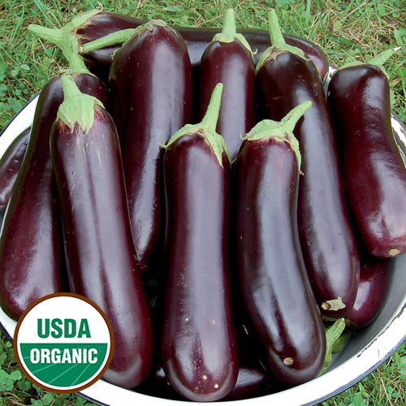
Diamond Eggplant

These dark purple beauties with green tinted flesh are slender, 9 inches by 3 inches in diameter. Deep eggplant flavor, texture, firm flesh, and rarely bitter. The fruits are borne in clusters of 4-6 on two-foot tall plants, are disease-resistant, and rarely bitter. Seed Savers Exchange collected the variety from the Ukraine in 1993.

Climate: Eggplant is very tender perennial, most often grown as an annual, requiring 100 to 140 warm days with temperatures consistently between 70° and 90°F to reach harvest. Transplant outdoors in full sun when soil is at least 55-60 degrees F.

Spacing: 18-24 inches apart.

Irrigation: Evenly moist soil. Do not over water or allow the soil to dry out.

Fertilizer: Granular Nature Safe 5-6-6 and Blood Meal, along with Compost Plus, Micros Plus, and Capacity Plus, used at VISTA at the beginning of the Fall season are good starter fertilizers to support root and leaf development. Once fruit begins to develop, switch to a phosphorus-rich fertilizer like bone meal to encourage healthy fruit development. At this point if over fertilized with nitrogen, they will grow excessive foliage and produce less fruit. A balanced tomato/vegetable fertilizer works well for continued, regular feedings.

Matures 70 days after transplant. The fruits weight up to 2 lbs

Seed source:
https://www.seedsavers.org/site/pdf/grow-save-eggplant.pdf

Eggplant is a compatible neighbor with and benefits from growing alongside many plants. It has no incompatibility issues! Read more about this in the following blog, that will surely provide inspiration for planning your garden.
https://insteading.com/blog/companion-planting-for-eggplant/

