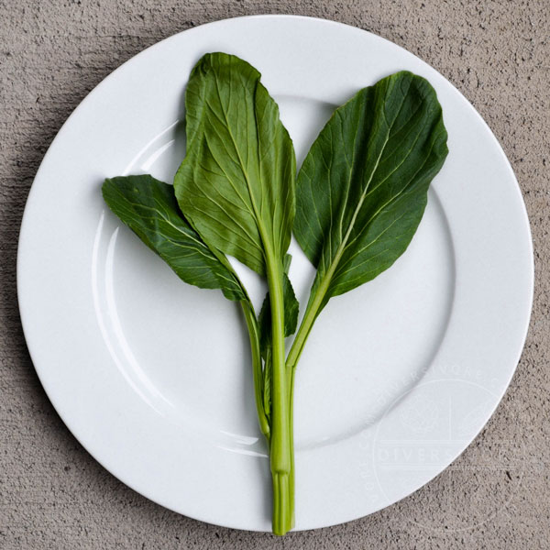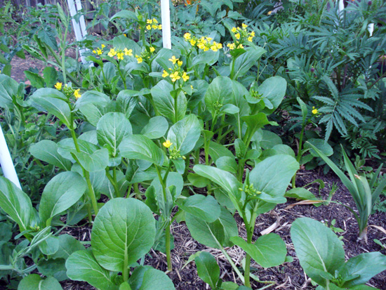
Flowering Brassica – Yu Choi Sum
Although technically a Chinese cabbage, does not form heads, but instead forms bunches of long, thick stalks. Fast-growing flowering brassica is called yu choi when harvested for the leafy greens and yu choi sum when the plant sends up a flower stalk and sets buds. Harvest the florets with the tender young leaves for great flavor and texture. Generally mild with a slight mustard-green flavor.

Culture: Prepare fertile, well-drained soil. Ideal temperature between 60-70˚F. Cover with shade cloth to protect from heat when temperature rises higher.

Spacing: Sow seeds ¼-½" deep, 4" apart and thin sprouts 12 to 18 inches apart from one another in all directions. Note: Sow short row every 2-3 weeks for continual harvest.

Irrigation: Keep soil moist. Avoid wetting foliage when watering the soil around choy sum. Also, refrain from using sprinklers or watering at the end of the day when the leaves will not have the chance to dry in the sun. Sprinklers or careless watering methods can lead to fungal diseases.

Fertilization: Side-dress plants with a 1-inch layer compost three weeks after sowing seeds. Set compost in rings around individual plants, or in narrow bands several inches in front of each row.

Maturity: Use a sharp knife to cut the plants at ground level when they are ready to harvest. Yu Choi Sum will not grow back like some other crops.

https://whitwamorganics.com/collections/fruits-veggies/products/yu-choi-sum-flowering-brassica-seeds?variant=8269739458605

Avoid planting near peppers and tomatoes.

