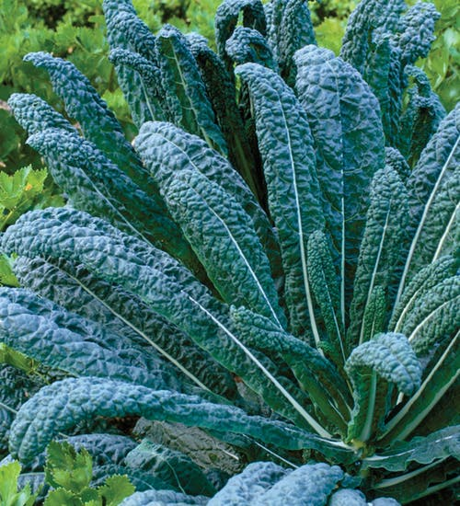
Nero Di Toscana Cabbage
This loose-leafed cabbage dates back to the early 1800s at least. It has beautiful, heavily savoyed, deep black-green leaves that can be 24 inches long. This Italian heirloom is popular in Tuscany and central Italy for making fabulous soups and stews and is one of the most beautiful and flavorful types you can grow. One of the healthiest vegetables we ever tested! It can have up to 3 times the recommended daily vitamin A, plus loads of minerals, calcium, and vitamin C, as well as lots of fiber and protein, truly a miraculous plant from historic Italy. Known by many names, you will hear VISTA gardeners refer to this as Dinosaur Kale.
Culture: Work in organic matter and tamp down to firm the soil. Ideal soil temperature 50-85°.
Spacing: If direct sowing, seed every 4-6 inches, ¼" deep and thin to mature spacing of 24” apart. If transplanting, allow plenty of space as these grow large and plant in firm – not loose – soil. Some VISTA gardeners plant them at the end in a corner of their raised garden bed.
Fertilize: Work in balanced fertilizer before transplanting, although do not work soil loosely, as transplants do best in firm soil.
Irrigation: Consistent moisture provides the best tasting leaves. Moist, but not soggy soil is ideal.
Maturity: 60 days. Harvest by clipping individual leaves from the bottom up at any size. Cut and come again right into late spring!
Very hardy, and the eating quality improves with light frost.
https://www.rareseeds.com/store/vegetables/bulk-vegetables/lettuce-and-greens/nero-di-toscana-cabbage-dinosaur-or-lacinato-kale
Compatible with beets, celery, cucumbers, dill, lettuce, nasturtium, onions, spinach, Swiss chard, and many herbs.
Incompatible with tomatoes and strawberries.

