Dwarf Jewel Mix Nasturtium
(Tropaeolum minus)
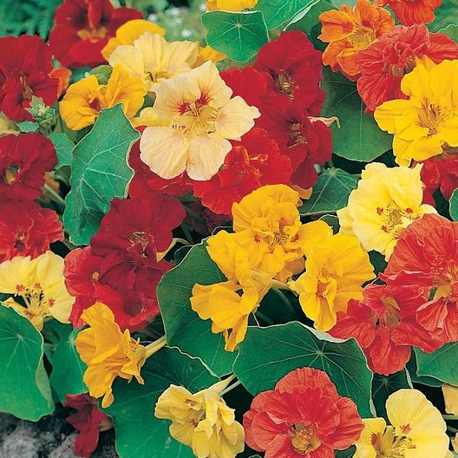
Nasturtiums are an easy to grow flowering annual with edible leaves, pods, and blooms. The flavor is described as similar to that of watercress. This plant has a bushy growth habit that is around 12” tall. Leaves are round and smooth, and its numerous semi-double and double flowers are red, orange, salmon, and yellow. Maturity is 32-40 days. Fertilization promotes vigorous leaf growth and fewer flowers. Self seeds easily.

Note: this variety does not tolerate excessive heat.

http://www.missouribotanicalgarden.org/PlantFinder/PlantFinderDetails.aspx?taxonid=264612&isprofile=0&

