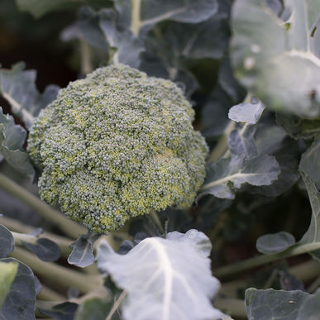
Broccoli – Marathon
Marathon has a high dome, small bead and heavy head. Heat tolerant but unique because it keeps growing even in cooler temperatures, so it is perfect for a fall crop in the South.

Spacing: 24" A one-inch layer of mulch keeps the soil surface much cooler and reduces the threat of bolting.

Irrigation: Regular, steady watering of 1-1½" per week is important during hot, dry weather. Overhead watering in hot weather can drop the temperature around the plants 10° F, due to evaporation, which is good for young plants, but should be avoided once heads start forming (to reduce the risk of soft rots setting into the crowns.)

Fertilization: Broccoli is a heavy feeder. See tips below.

Matures in 75 days. Fertilize when first head is cut to get more side shoots and an extended harvest.

For companion planting benefits, plant broccoli with herbs, potatoes, or onions; avoid planting with tomatoes or pole beans.
Extra Growing Tips:

The trick to producing good broccoli is to keep it growing steadily. Two to three weeks after transplanting, top dress with compost tea or side-dress with blood meal or fish emulsion, and water deeply. Repeat monthly until a week before harvesting the flower head. This regimen also encourages large and tender side shoots, which you can harvest until hot weather or a heavy ground freeze ends the broccoli season.

Cultivate around young plants to get rid of weeds and keep the soil loose. If daytime temperatures exceed 75°F, put down a thick layer of organic mulch to cool the soil and conserve moisture. Broccoli needs steady 1 - 1½ inches of water a week (slightly less during fall months.) A lack of water will result in tough stems, so soak plants extra well during dry spells.

