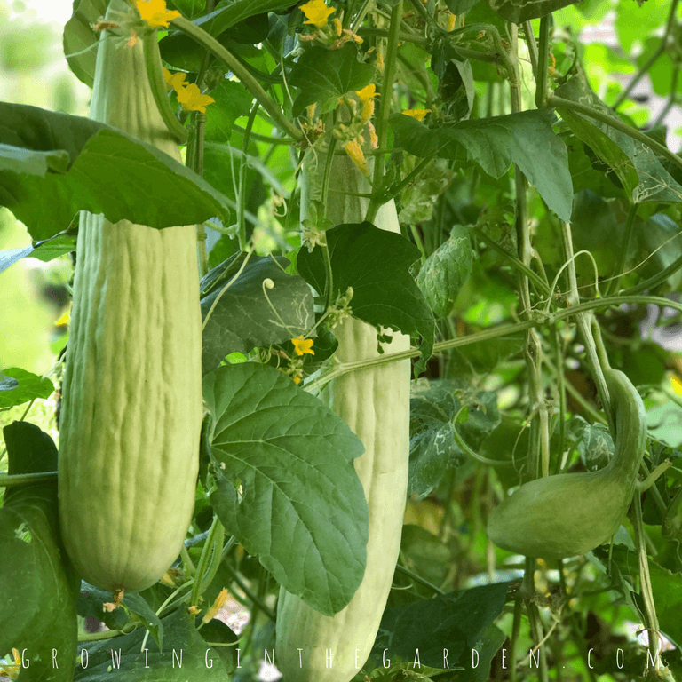
Armenian Cucumber
Sometimes referred to as snake melon, serpent and yard long cucumber. This variety is light green, heavily ribbed, and spineless. Fruits are crisp, mild and sweet flavored. It is a burpless cucumber and its thin skin does not require peeling. Very heat tolerant.
Culture: Ideal soil temperature is 78-86˚F. Ideal soil pH between 6 and 7. Optimum growing temperatures are 75°F daytime and 60 F at night.
Spacing: Sow seeds 1" deep, 2-4" apart. Thin to 10-12"
Trimming and Staking: Train to climb a vertical support for better air circulation, straighter fruits and ease of harvest.
Keep the primary vine and support with trellis. Each node on the vine has a tendril (important for attaching to trellis and/or stake), a fruit, a leaf (important for photosynthesis), and a growth point. Prune growth points for improved plant health and production.

Helpful video on pruning growth points: https://www.youtube.com/watch?v=TGkFJh5bKGg

Irrigation: Keep soil moist.

Fertilization: Granular Nature Safe 5-6-6 and Blood Meal, along with Compost Plus, Micros Plus, and Capacity Plus, used at VISTA at the beginning of the Fall season are good starter fertilizers to support root and leaf development. Additional fertilizer should be given when female flowers bloom. Side dress with well-cured compost (typically low in nitrogen) or apply water-soluble, low-nitrogen, higher potassium fertilizer weekly at half strength (usually ½ tablespoon in one gallon of water).
Maturity: Harvest in 65-70 days.
Use in salads and for pickling. Marinate in su (rice) vinegar (universal Japanese sweet/sour dressing) for a refreshing salad.
https://www.kitazawaseed.com/seed_015-22.html

