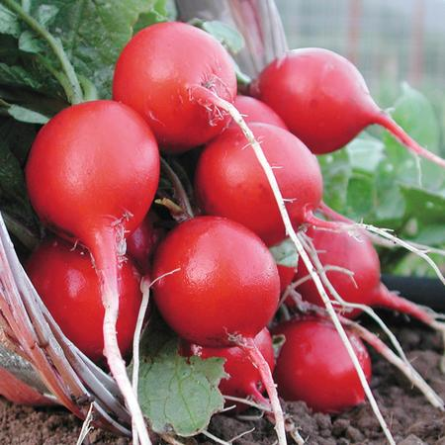
Cherry Belle Radish
Round roots, bright red skin, and firm white flesh. Somewhat less susceptible to developing pithiness compared to other varieties. Our sweetest spring radish.

Culture: Optimum soil pH between 5.5 and 6.8. Loosen top 6"of well draining soil and work compost into the top 2".

Spacing: Sow seeds in moist soil, 3/4" apart, 1/2" deep in rows 8-12" apart and thin to 1-1/2". Planting successively every week allows for continuous harvesting.

Irrigation: If plants do not receive one inch of rain weekly, water deeply. Drought stress can cause the roots to develop poor flavor and a tough texture.

Fertilization: Radishes do not require additional fertilization after they are planted. Be careful not to use nitrogen-rich fertilizers near radishes, as you will prompt leaf growth at the expense of radish root.

Maturity: 24 days.

https://www.southernexposure.com/products/cherry-belle-radish/

Plant radishes near beans, beets, celeriac, chervil, cucumber, lettuce, mint, parsnip, peas, spinach, squash, and tomatoes. Avoid planting near potatoes.

