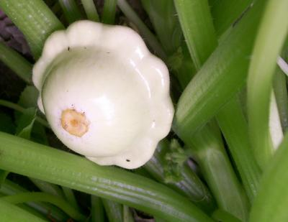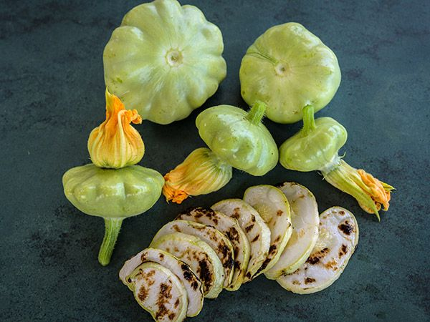
Benning’s Green Tint

One of the most beautiful and hardy varieties of Patty Pan squash. Saucer-shaped fruits with scalloped edges and pale-green, fine-textured flesh of good flavor. Harvest when small.

Culture: Ideal soil pH 5.8-6.8. Prepare fertile, well-drained soil and form a 1-foot diameter mound 3-4" high. Space mounds 4 feet apart.

Spacing: Sow 4-5 seeds per mound 1/2" to 1" deep and 2" apart. Ideally, mounds are 4 feet apart. Note: Be careful not to overwater germinating seeds or they may rot. Succession plant every 3 weeks.

Irrigation: To determine if plants need watering, dig 3-4 inches into the soil next to the plants. If the soil is dry, it is time to water. Add approximately 1-2 inches of water once each week when it does not rain. Focus a slow stream of water at the base of the plants to avoid watering the tops of the plants (which may encourage diseases to develop). Make sure that the water does not erode any of the soil away from the base of the plants. Exposed roots will lead to insect problems and under-performing plants. Like all plants, squash use water to extract nutrients from the soil and your plants will not be healthy if they don't get enough essential nutrients.

Fertilization: Fertilize when the seedlings first emerge, when blossoms appear, and when plants begin to set fruit. A balanced, water soluble fertilizer is ideal.

Matures in 52 days, although if picked when almost bite size and with the edible flower still attached, they are deliciously tender. Roast or grill them whole with a dash of salt and pepper, olive oil and herbs.

https://www.southernexposure.com/products/benning-s-green-tint-summer-squash/

Squash is compatible to grow with corn, lettuce, melons, peas, and radish. Avoid planting near Brassicas or potatoes. Borage is said to improve the growth and flavor of squash. Marigolds and nasturtium repel numerous squash pest insects.

