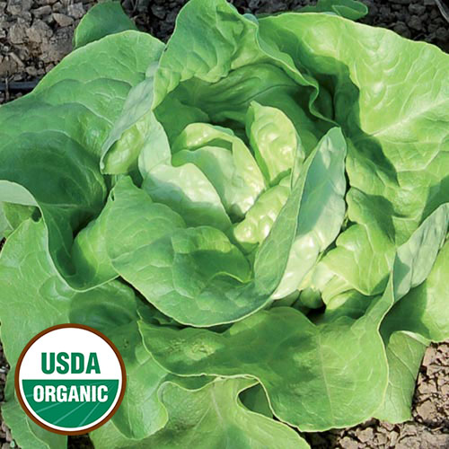
Mantilia Lettuce
A large and beautiful chartreuse butterhead lettuce that scored in the top 10 in Seed Savers Exchange’s 2010 lettuce tasting of over 70 varieties and remains popular. This mild, tender, and sweet lettuce has floppy leaves and is slow to bolt.
Culture: Ideal soil pH is 6.0-6.5, rich with organic matter and well-draining. Lettuce is a cool-weather crop that thrives in the temperature range 60-65 degrees F, and if thoroughly hardened, most varieties survive temperatures as low as 20 degrees F.
In Central Florida it helps to plant lettuce underneath a leaf canopy so that it is shaded during the hottest portion of the day. (See companion plants below for likely shady plants in your garden.)
Spacing: Sow seeds ¼" deep, 1" apart. After they germinate (in 7-14 days) thin sprouts so that they are 6-8" apart. Sow continuously for a constant supply of lettuce. Good air circulation should be maintained around the plants and soil should be kept clean to reduce the presence of pests and disease.
Irrigation: Regular watering is essential to prevent leaves from getting bitter. Lettuce leaves are mostly water and will desiccate and wilt in strong sunlight and dry soil. Lettuce roots tend to be shallow, so frequent watering is more important than deep watering.
Fertilizer: Feed every two weeks, alternating a balanced granular fertilizer with a foliar liquid seaweed or fish emulsion. If you grow lettuce in irregular patterns, create a 1-inch shallow trench 6 inches from each plant into which you sprinkle granular fertilizer, gently mix into the soil, and water. If you grow lettuce in rows, run a narrow band along each row of lettuce plants, fertilize and water.
Matures in 60 days (or 10-14 days earlier if transplanted).
Note: The glucose content of lettuce harvested in the morning may be 2-1/2 times greater than lettuce harvested in the early afternoon. For best quality and maximum sweetness harvest by 7-8 am, especially when it is warm.
https://www.seedsavers.org/mantilia-organic-lettuce
https://www.southernexposure.com/lettuce-growing-guide/
Lettuce is compatible with beets, Brassicas, carrot, celery, cucumbers, onions, radish, spinach, squash, and strawberries.
https://www.westcoastseeds.com/blogs/garden-wisdom/companion-planting

