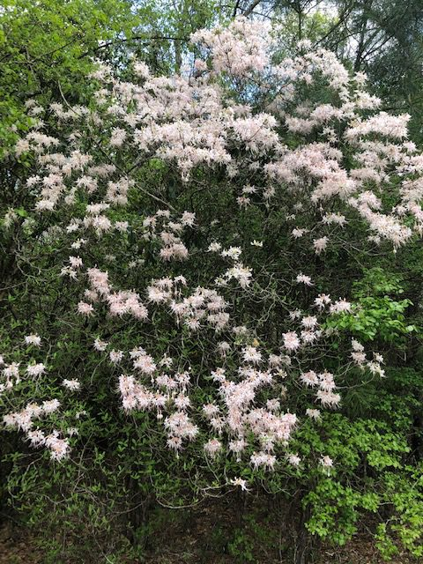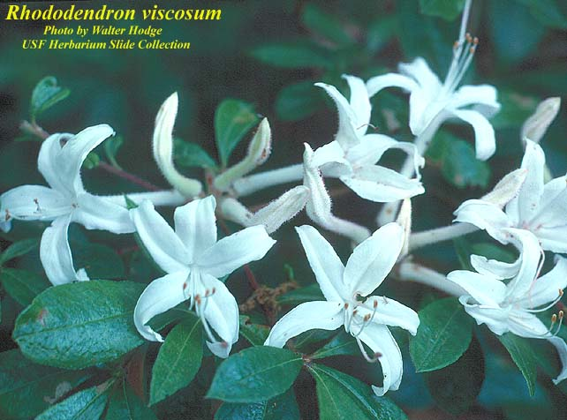

SWAMP AZALEA
Rhododendrum Viscosa
Swamp azalea, Florida’s only white-flowered and summer-blooming rhododendron, is a long-lived perennial shrub to small tree that can grow from 5 to 15 feet tall and 12 feet wide. Occurs naturally in wet flat woods, seep and bay swamps and along lake margins.

Deciduous leaves are elliptic, pubescent and alternately arranged. Flowers late spring through summer after the leaves emerge with fragrant white blooms often tinged with pink. The long corolla is tubular and covered in sticky, gland-tipped hairs. It opens into five lobes, exposing five conspicuous stamens that extend well beyond the corolla.

Attractive to a variety of pollinators, including hummingbirds.

https://www.fnps.org/plants/plant/rhododendron-viscosum

https://florida.plantatlas.usf.edu/Photo.aspx?id=2950

http://blogs.ifas.ufl.edu/escambiaco/2020/03/26/weekly-what-is-it-native-azaleas-2/

