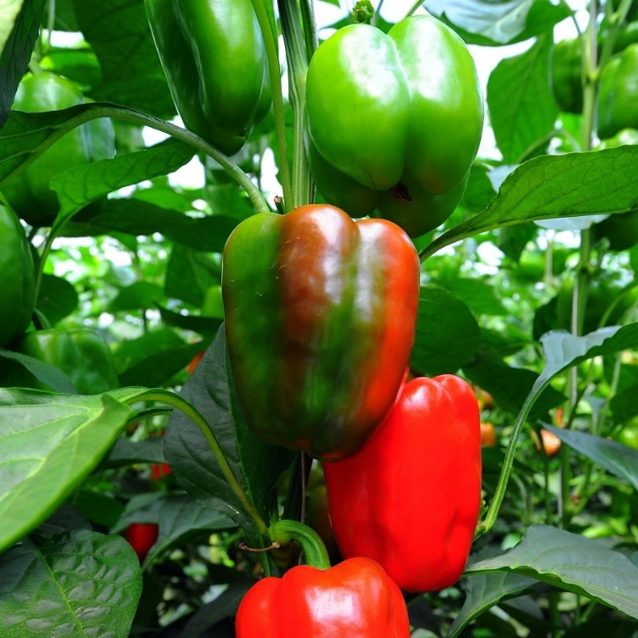
California Wonder
Large, blocky, thick-walled glossy 3.5” fruit sweet in flavor and perfect for stuffing. Upright, everbearing habit keeps fruit high on 24-30" plants. Heirloom that is resistant to Tobacco Mosaic Virus.
Climate: Full sun. Ideal soil temperature 65-85˚F. Best soil pH between 6.0-6.8. Well-draining soil rich with organic amendments.
Spacing: 14-16 inches apart in raised beds
Irrigation: Water the plants regularly, giving them at least 2 inches of water per week during dry weather. Check the soil moisture by sticking your finger into the soil; water any time it feels dry an inch beneath the surface. Irrigate the base of the plant and avoid getting water on the foliage. Keep soil constantly moist, but not soaking wet.
Fertilizer: Granular Nature Safe 5-6-6 and Blood Meal, along with Compost Plus, Micros Plus, and Capacity Plus, used at VISTA at the beginning of the Fall season are good starter fertilizers to support root and leaf development. Feed the plants every four to six weeks with a fertilizer low in nitrogen and high in phosphate and potassium or with fish emulsion.
Matures 60 days (green) or 75 days (red) after transplant.
https://gardeningsolutions.ifas.ufl.edu/plants/edibles/vegetables/peppers.html
https://www.rareseeds.com/store/vegetables/peppers/sweet/california-wonder-pepper
Peppers are compatible with tomatoes, carrots, cucumbers, radishes, squash, eggplant, spinach, lettuce, chard, onions, and peas. They benefit from the company of nasturtiums, geraniums, and petunias.

Peppers are incompatible with pole beans, mustards, soybeans, lima beans, fennel, cabbage, broccoli, Brussel sprouts, cauliflower, collards, kale, turnips, and strawberries.

