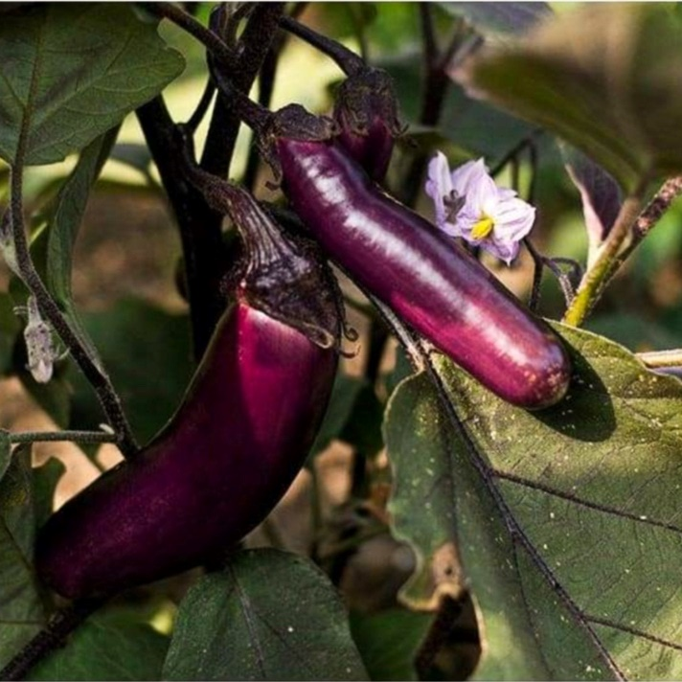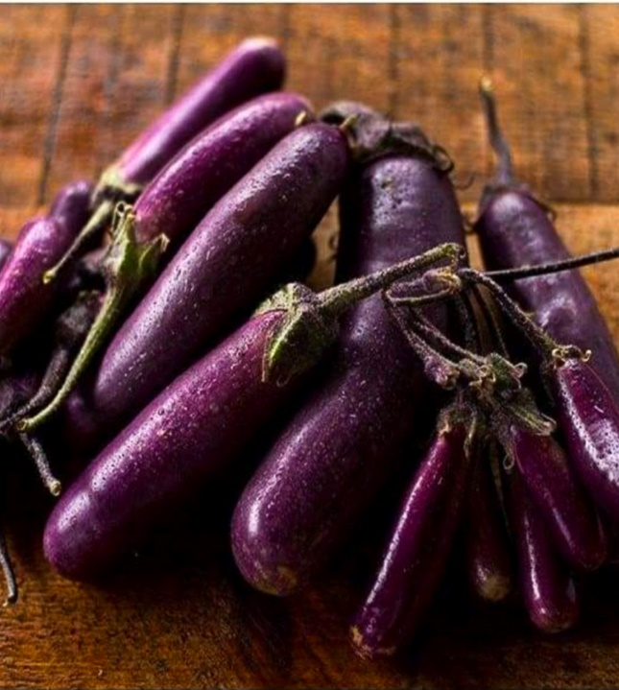
Slim Jim Eggplant

Long, slender, and purple. Mild flavor. A dwarf version, Slim Jim grows 27 inches high and 17 inches wide.

Culture: Eggplant is very tender perennial, most often grown as an annual, requiring 100 to 140 warm days with temperatures consistently between 70° and 90°F to reach harvest. Grows best in full sun and fertile, moist, well-drained sandy and loamy soils with a pH of 5.5 to 6.5.

Spacing: 18-24 inches apart.

Irrigation: Evenly moist but not soggy soil. Eggplants need moisture for fruit development and should be watered consistently, especially in dry conditions. Try not to allow the soil to dry out. Mulching helps to moderate soil temperature as well as to maintain soil moisture.

Fertilizer: Once fruit begins to develop, switch to a phosphorus-rich fertilizer like bone meal to encourage healthy fruit development. At this point if over fertilized with nitrogen, they will grow excessive foliage and produce less fruit. A balanced tomato/vegetable fertilizer (including calcium) works well for continued, regular feedings. Fertilizing twice during the growing season is typically sufficient for eggplants.

Matures 60 days after transplant. Harvest the first fruits when they reach usable size. This helps accelerate the growth of the other eggplants on the plant. Small fruits, 4-5 inches, have the best eating quality. Fruits are ripe when the skin appears glossy and fruit is resilient to thumb pressure.

Eggplant is a compatible neighbor with and benefits from growing alongside many plants. It has no incompatibility issues! Read more about this in the following blog, that will surely provide inspiration for planning your garden.
https://insteading.com/blog/companion-planting-for-eggplant/

