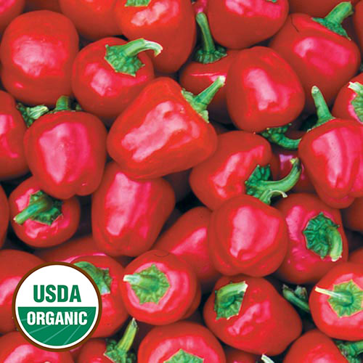
Miniature Red Bell Pepper
Short stocky plants covered with lovely 2" long miniature bell peppers with an excellent fresh flavor. A friend gave the yellow and red versions to Seed Savers Exchange member Lucina Cress of Ohio, who stuffed the peppers with cabbage, pickled and canned them to sell at her church bazaar. Great for salads.

Space seedlings 12-24 inches apart. Transplant into warm soil

Maturity/Harvest: 90 days

