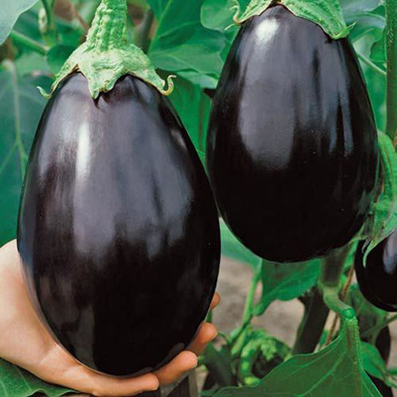
Black Beauty Eggplant

An heirloom variety, it bears classically shaped, glossy, purple-black fruits that are delicious grilled, baked, and in stir-fries.

Climate: Eggplant is very tender perennial, most often grown as an annual, requiring 100 to 140 warm days with temperatures consistently between 70° and 90°F to reach harvest.

Spacing: 24-36 inches apart.

Irrigation: Evenly moist soil. Do not over water or allow the soil to dry out.

Fertilizer: Eggplants are heavy feeders. Sensitive to nitrogen; if over fertilized, they will grow excessive foliage and produce less fruit. Use a high phosphorous starter.

Matures 80 days after transplant. The fruits weight up to 2 lbs.

