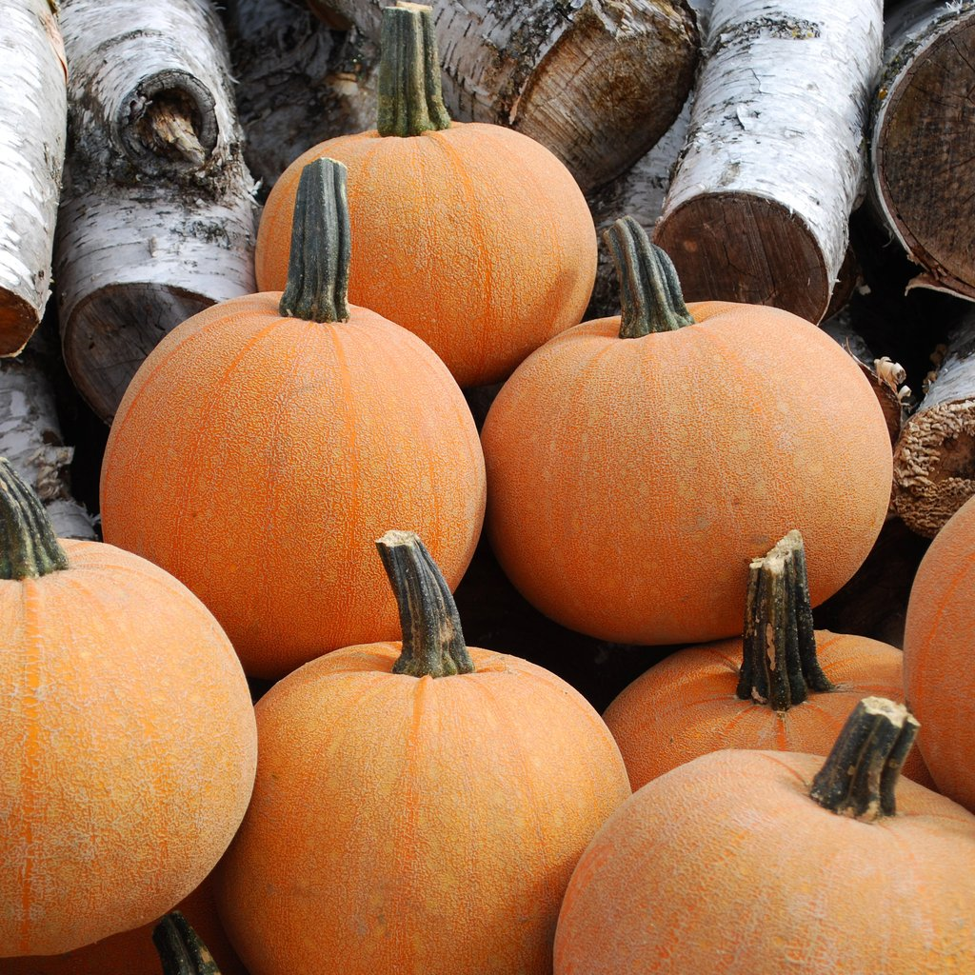
Pumpkin – Winter Luxury, Organic
Cucurbita pepo
Germination: 5-10 Days
Height at Maturity: 6"-8"
Days To Harvest: 90 Days
Sun/Shade: Full Sun
Spacing After Thinning: 18"-24"
Heirloom – A small pumpkin with a unique, fine netted skin. Fruit weights 5-7 lbs. The sweet and smooth textured flesh is wonderful for pies.
For more info, read reviews at:
https://www.rareseeds.com/winter-luxury-pie-pumpkin/

