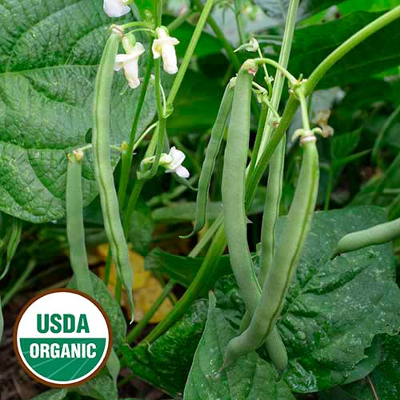
Bush Bean - Empress

Our very best snap bean for fresh eating, freezing, or processing, the Empress bean offers incredible flavor. The vigorous plants produce heavy yields of large, straight, green, 5-6” stringless pods.

Culture: Light, well-drained soil with pH of 6.0-6.2.

Spacing: Direct sow seeds 1" deep, 2" apart in rows 3' apart. Press down the earth above them for good soil contact. Sow a few times a season, 2-4 weeks apart for a continuous harvest.

Irrigation: Beans have shallow roots and need regular watering if the weather is dry. Provide adequate, even moisture, especially at flowering time. Dry soil can result in low yields and fibrous pods.

Fertilizer: Do not over fertilize with nitrogen which results in a surplus of foliage and low, delayed pod growth. A side-dressing of compost may be sufficient, although some gardeners add a low nitrogen fertilizer at the time of flowering.

Matures in 55 days Note: Harvest frequently for increased yields.

7/15/2020 Review from North FL grower:
“Nearly 100% germination with wet paper towel in a plastic bag. Leaves get hammered in the 90+ degree Florida sun, however they are solid producers from a raised bed watered twice weekly.”

https://www.seedsavers.org/empress-organic-bean

For companion planting benefits, grow beans near carrots, cucumbers, or corn; avoid planting them near onions.

