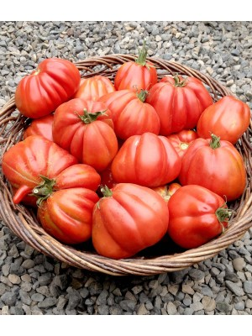

Tipo Albenga* Tomato
Great in a stew of white beans, kale, and roasted tomatoes, pasta e fagioli, or a just simple rustic pasta sauce. Excellent sliced and eaten raw, but the variety really shines with roasting, as it brings out the savory richness of flavor.

Indeterminate: Train to a vertical support

Space seedlings 24-36 inches apart. Transplant so that soil level is just below the lowest leaves.

Plant in fertile soil, amended with compost. Provide even moisture. Plant deeper than they were growing in the containers as it makes a stronger roots system. Apply a light compost tea every few weeks. Do not apply excessive nitrogen, which can promote excessive foliage and poor fruit set.

Maturity/Harvest: 85 days

Tomatoes are incompatible with broccoli, cauliflower, corn, and dill. Carrots grown with tomatoes will have good flavor but stunted roots. Compatible with basil, beans, chives, cucumbers, garlic, lettuce, marigolds, nasturtium, onion, parsley, and rosemary; all of which help control pests.

*From Ligurian coast town of Albenga, just west of Genoa, in Northern Italy – seeds brought from Italy by VISTA gardener, Lori Vella, whom we thank!

