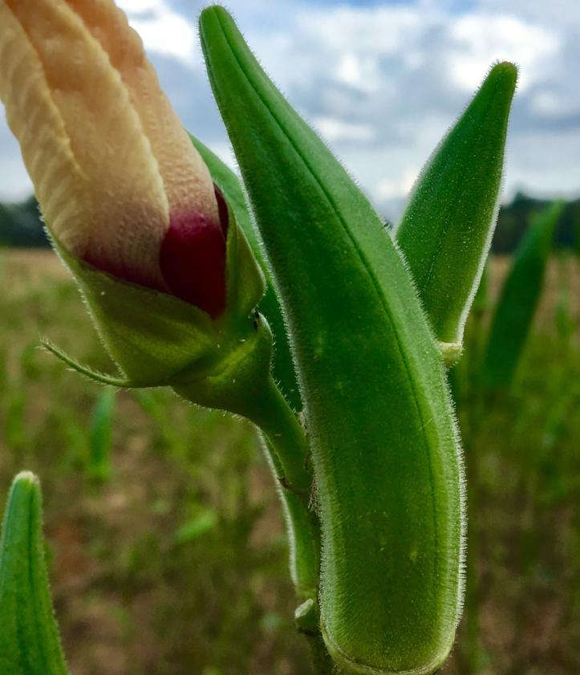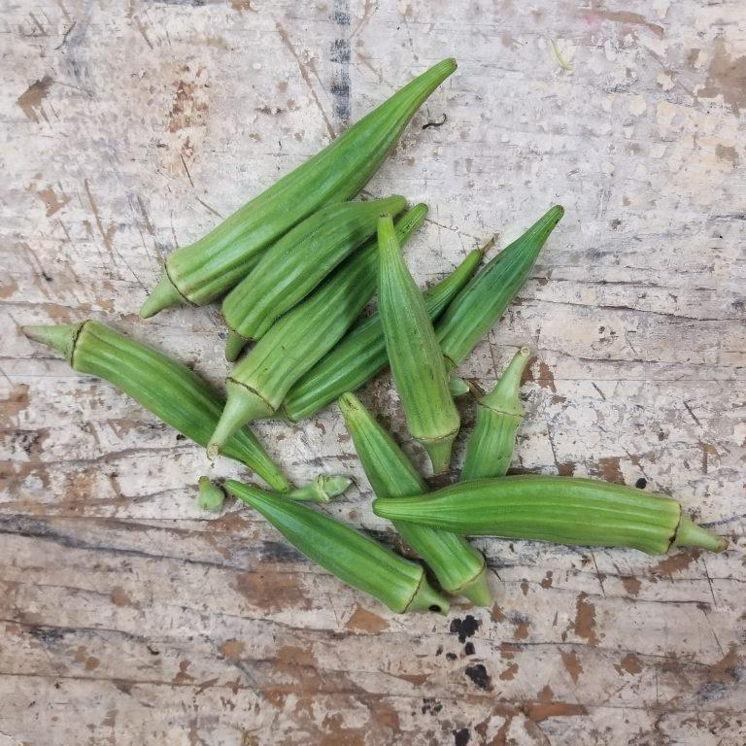
Okra – Bradford Family
The Bradford Family okra has been grown and passed down in Sumter, SC for almost as long as their famous watermelon. In the mid 1900’s Theron Bradford built an okra thresher to harvest the seed from his crop and supplied all the local feed and seeds in Sumter and surrounding counties. It was unique in that the tip of the okra would still snap clean at even 6-8 inches in length, meaning that it was a very large tender pod. Nat Bradford, Theron's grandson, is now the breedline manager for his family's heirloom okra. Over the summer of 2017 Nat introduced this okra to SC chefs who have placed it in high demand. Chef Forrest Parker, impressed with its size and tenderness, commented "Wow! This okra is large enough to stuff! This changes everything we know about okra." Chef Kristian Niemi commented that he had never tasted such a sweet okra. And Chef Sean Brock referred to the pearl-like seeds as he pressed them from a large pod that "this is okra caviar!"Now, after close to three quarters of a century, the Bradford family is making this fabulous, rare okra available again!

Culture: Direct sow in soil with temperatures between 70-90°F. Requires full sun and well-drained soil. It will tolerate a wide variety of soils and once established is heat and drought tolerant.
Sowing Seed: Direct sow seeds ½ inch deep, spaced 3-4 inches apart. Thin to mature spacing of 12 inches apart. Note: Okra has a thick seed coat and does not germinate easily. Soak seeds in water at room temperature overnight and/or nick hard seed coat prior to planting for improved germination.

Irrigation: Okra will tolerate some drought conditions, but in hot weather, make sure it gets at least an inch of water per week. Water the base of the plants and slowly enough so as not to erode the soil away. Avoid watering the tops of the plants as wet foliage is a breeding ground for fungi. Ideally, water in the early morning hours, so that the day’s sunlight evaporates any excess water that was not absorbed into the soil.
Fertilizer: Amend garden soil with compost before planting. When seedlings are 6 inches tall, apply a well-balanced fertilizer and follow up with a water soluble fertilizer (e.g. fish or seaweed emulsion) every 4 weeks.
Matures in 60 days. Depending on the variety, pods are best eaten when 2-3" long, and if left on plant too long, they become tough and fibrous. To increase productivity of plants, harvest every two days to promote further pod production.

https://sowtrueseed.com/products/bradford-family-okra
Some of okra's best garden companions are plants that, like okra, need plenty of water. This includes cucumbers, melons, eggplant, and sweet or hot peppers.
Okra is useful as a shade plant to extend the growing season for “interplanted” lettuce, peas, and radishes.
Planting okra near tomatoes, peppers, and beans can reduce pests. For example, peppers repel cabbage worms that feast on young okra foliage. Planting basil near okra is also beneficial, as the strong fragrance repels pests that like okra, including flea beetles, stinkbugs, spider mites, aphids and whiteflies. Okra's tall plants, which can grow up to six feet, can also provide shade for the basil.
Planting sunflowers near okra assists with pollination. Although okra does not have incompatible plants, it is often advised not to plant okra where squash and sweet potatoes have been grown, as they are known to attract non-beneficial nematodes.

