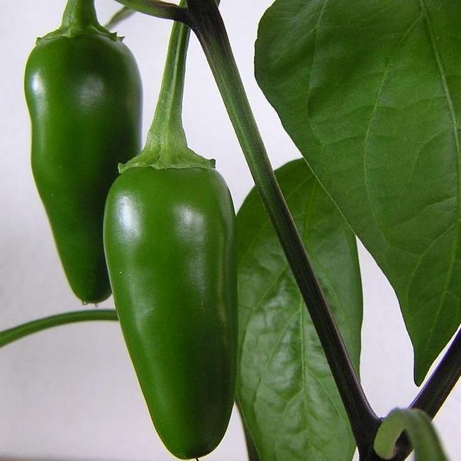
Tam Jalapeño Pepper
Take a break from the heat without losing flavor! A quarter to half as hot as early jalapeño, this pepper has excellent yields and is ideal for pickling, canning, and freezing.
Climate: Full sun. Ideal soil temperature 65-85˚F. Best soil pH is around 6.5.
Spacing: 18-24 inches apart
Irrigation: Water the plants regularly, giving them at least 2 inches of water per week during dry weather. Check the soil moisture by sticking your finger into the soil; water any time it feels dry an inch beneath the surface. Irrigate the base of the plant and avoid getting water on the foliage. Keep soil constantly moist, but not soaking wet.
Fertilizer: Granular Nature Safe 5-6-6 and Blood Meal, along with Compost Plus, Micros Plus, and Capacity Plus, used at VISTA at the beginning of the Fall season are good starter fertilizers to support root and leaf development. two to three times throughout the growing season or select a controlled release fertilizer for season-long feeding. Once you plants begin to produce fruits, reduce the amount of nitrogen in your fertilizer as too much nitrogen in the soil can cause your pepper plants to produce little or no fruits.
Matures 63 days (yellow) or 83 days (red) after transplant.
https://gardeningsolutions.ifas.ufl.edu/plants/edibles/vegetables/peppers.html
https://sowtrueseed.com/products/hot-pepper-tam-jalapeno
Peppers are compatible with tomatoes, carrots, cucumbers, radishes, squash, eggplant, spinach, lettuce, chard, onions, and peas. They benefit from the company of nasturtiums, geraniums, and petunias.

Peppers are incompatible with pole beans, mustards, soybeans, lima beans, fennel, cabbage, broccoli, Brussel sprouts, cauliflower, collards, kale, turnips, and strawberries.

