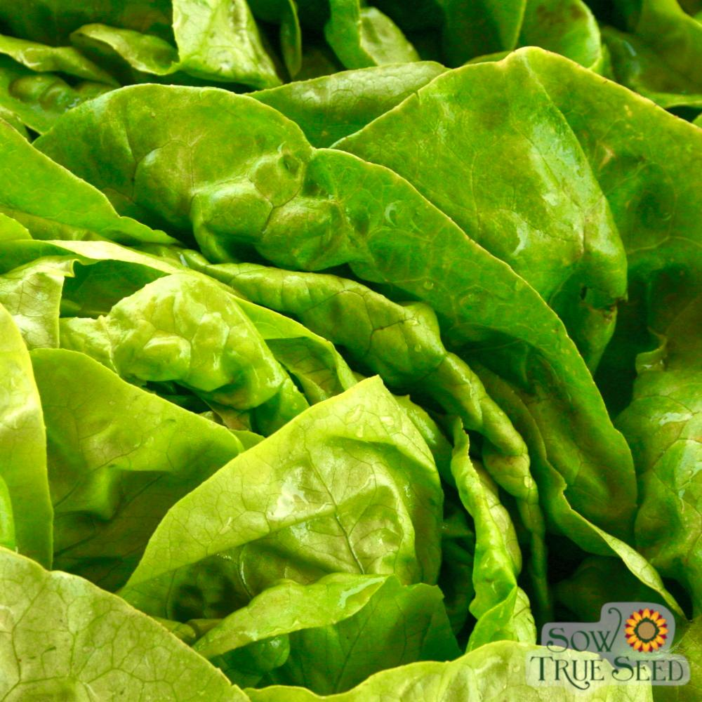
Buttercrunch Lettuce
Buttery, crunchy, chewy leaves with a crisp heart - one of the best all round lettuces deserving of so many adjectives. Heat tolerant and slow to bolt.
Culture: Ideal soil pH is 6.0-6.5, rich with organic matter and well-draining. Ideal soil temperature is 40-80 degrees F. Frost tolerant.
In Central Florida it helps to plant lettuce underneath a leaf canopy so that it is shaded during the hottest portion of the day. (See companion plants below for likely shady plants in your garden.)
Spacing: Sow seeds 1/8" deep, 1/2" apart. After they germinate (in 3-15 days) thin sprouts so that they are 6-10" apart. Good air circulation should be maintained around the plants and soil should be kept clean to reduce the presence of pests and disease. Sow a row or small patch every 7 to 10 days throughout spring or fall. This successive method offers a continual harvest; you are likely to have some lettuce plants reaching maturity while other plants are bolting and others are germinating.
Irrigation: Regular watering is essential to prevent leaves from getting bitter. Lettuce leaves are mostly water and will desiccate and wilt in strong sunlight and dry soil. Lettuce roots tend to be shallow, so frequent watering is more important than deep watering.
Fertilizer: Feed every two weeks, alternating a balanced granular fertilizer with a foliar liquid seaweed or fish emulsion. If you grow lettuce in irregular patterns, create a 1-inch shallow trench 6 inches from each plant into which you sprinkle granular fertilizer, gently mix into the soil, and water. If you grow lettuce in rows, run a narrow band along each row of lettuce plants, fertilize and water.
Matures in 50 days (or 10-14 days earlier if transplanted).
Note: The glucose content of lettuce harvested in the morning may be 2-1/2 times greater than lettuce harvested in the early afternoon. For best quality and maximum sweetness harvest by 7-8 am, especially when it is warm.
https://sowtrueseed.com/collections/best-sellers/products/lettuce-buttercrunch-organic?_pos=1&_sid=08637fbee&_ss=r
Sow Tree Seed blog, “The Complete Guide to Growing Lettuce from Seed to Seed”
https://sowtrueseed.com/blogs/planting/lettuce-the-complete-guide-to-growing-lettuce-from-seed-to-seed?_pos=3&_sid=840cb68cf&_ss=r

Lettuce is compatible with beets, Brassicas, carrot, celery, cucumbers, onions, radish, spinach, squash, and strawberries.
https://www.westcoastseeds.com/blogs/garden-wisdom/companion-planting

