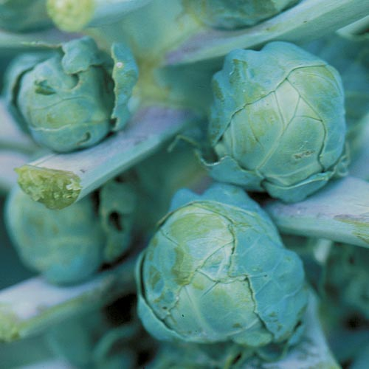
Brussels sprouts, Long Island Improved
Tall 30-36"plants yield 50-100 dark green 1½ inch sprouts over an extended period. Transplant in late fall, as they require cool temperatures to develop firm, crunchy sprouts. Warm weather causes individual sprouts to be soft and open rather than solid and tightly packed. An ideal average temperature is around 58–60°F. http://edis.ifas.ufl.edu/mv034
Spacing: 24 inches. Support plants, as upright Brussels sprouts plants produce better than crooked ones. Plants reach a height of 30-36 inches.
Irrigation: Keep plants watered regularly and soil moist. They need 1-1 ½ inches of water weekly.
Fertilization: Brussels sprouts are heavy feeders that demand moist, fertile soil. Mix in balanced organic fertilizer when transplanting. Fertilize again when 12" high and repeat every three to four weeks.
Mature in 80-115 days from transplant. Harvest after they reach 1-1 ½" and become fairly firm but before they are tough and yellow. The first sprouts near the bottom of the plant are ready about 3 months after planting.
Pull off the leaves below the mature sprouts, then remove the sprouts by twisting them from the stem. Pick the sprouts as needed, but usually at about 2-week intervals. Continue harvesting as long as good sprouts are formed. The stalk is edible and much tastier with outer layer removed.
Growing Tip: Removing the terminal growth tip when the plants are 15–20 in. tall makes the sprouts grow larger and mature more quickly. Do not disturb soil around plant as roots are shallow and susceptible to damage.
Brussel Sprouts are incompatible with pole beans, kohlrabi, and strawberries.

